Name: ____________________________ Surname: ____________________________ N^{ber}: ____ Grade/Class: _____
Assessment: _____________________________ | Date: ___________________________________________________
 | Teacher’s signature:  ___________________________ | Parent’s signature:  ___________________________

- Look at the pictures and say.
- How do they feel?
- She is…
 | 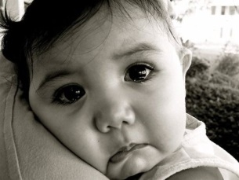 | 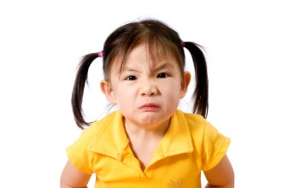
Emily | Stacy | Barbara

- Look at the pictures again and say:
- Who is happy?
- Who is sad?
- Who is angry?

Answer key
- She is happy. She is sad. She is angry.

- a) Emily is happy.
b) Stacy is sad.
c) Barbara is angry.

