Name: ____________________________ Surname: ____________________________ N^{ber}: ____ Grade/Class: _____
Assessment: _____________________________ | Date: ___________________________________________________
 | Teacher’s signature:  ___________________________ | Parent’s signature:  ___________________________

- Look at the pictures of Spike and say:
How is Spike?
Spike is ….
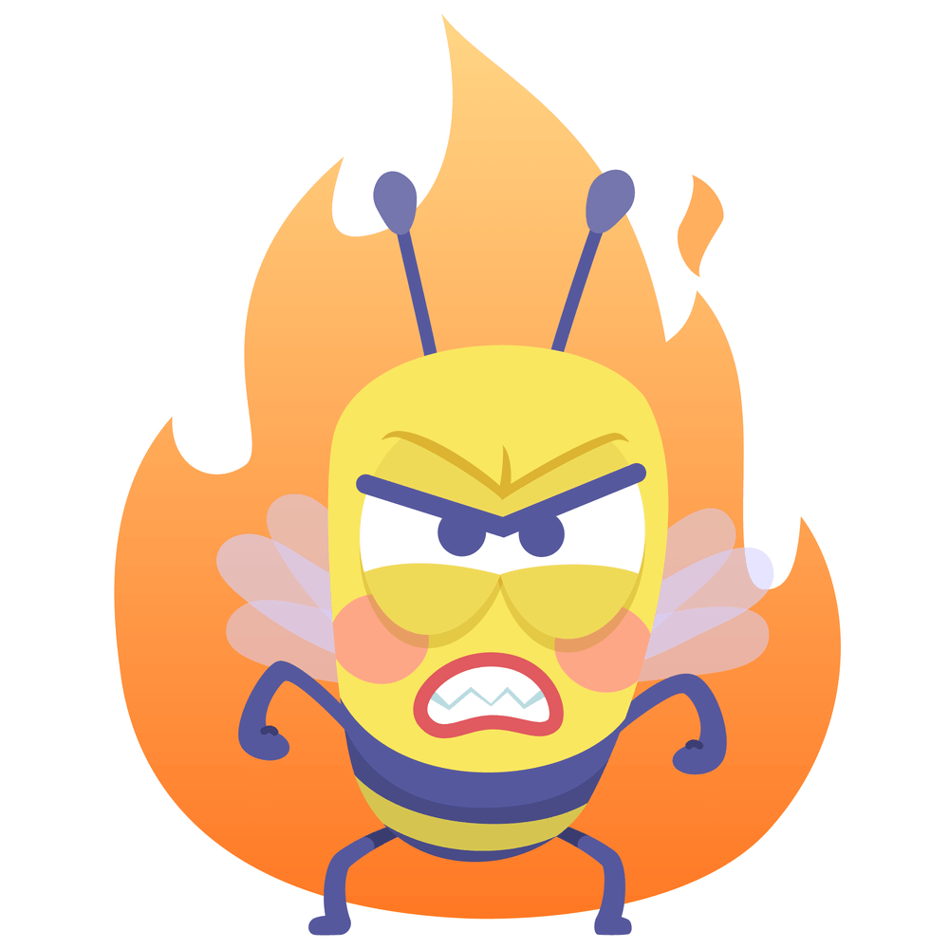 | 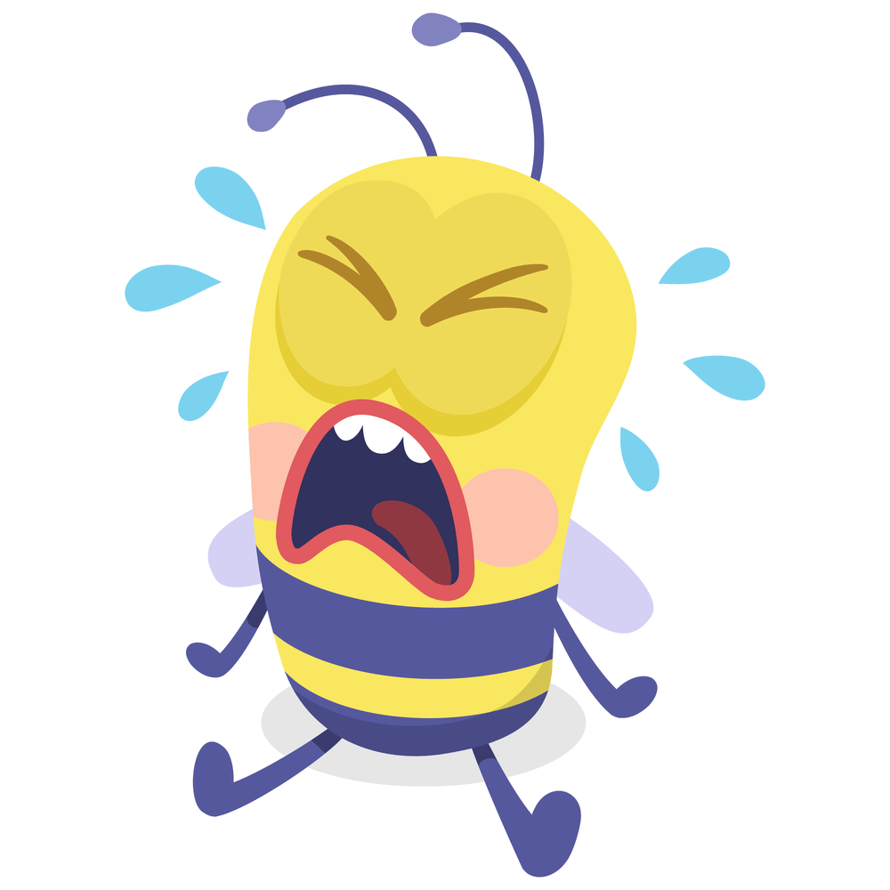 |  | 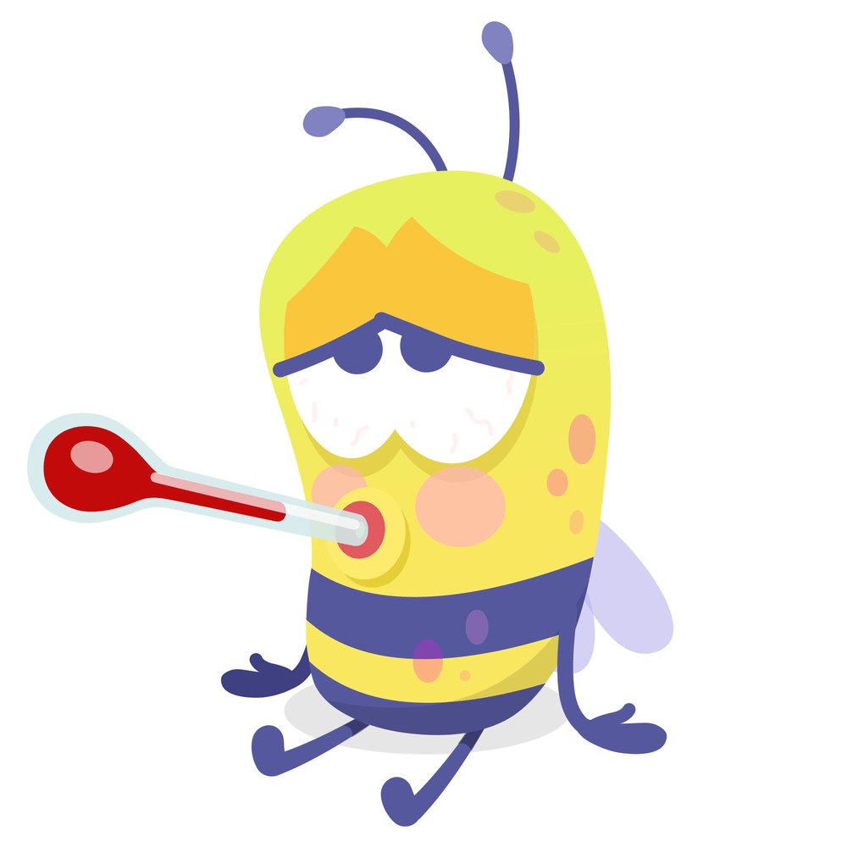

2. How are you today?

Answer key
- Spike is angry. Spike is sad. Spike is happy. Spike is sick.

- I’m happy, sad ….

