Name: ____________________________ Surname: ____________________________ N^{ber}: ____ Grade/Class: _____
Assessment: _____________________________ | Date: ___________________________________________________
 | Teacher’s signature:  ___________________________ | Parent’s signature:  ___________________________

- Look at the pictures and say:
How are they?

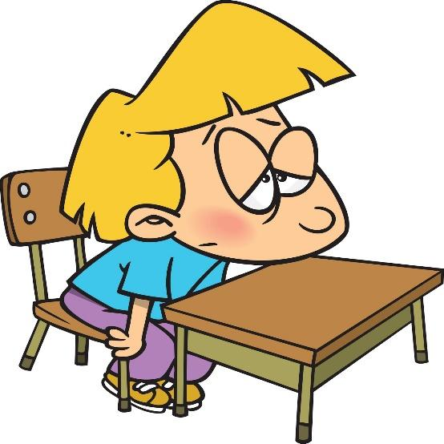
Adam and Sally Bob

2. Are you happy today?
Are you tired?

Answer key

- Adam and Sally are happy. Bob is tired.

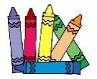
- Yes, I am / No, I’m not.

