Name: ____________________________ Surname: ____________________________ N^{ber}: ____ Grade/Class: _____
Assessment: _____________________________ | Date: ___________________________________________________
 | Teacher’s signature:  ___________________________ | Parent’s signature:  ___________________________

- Match the pictures with the correct feeling.

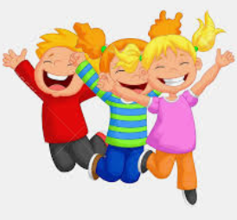

sleepy happy angry tired

- Complete the words.

- It is my birthday. I am h_________y.
- You are in bed. You are s_____.
- You cry. You are s________.

Answer key

- Happy, tired, sleepy, angry

- Happy, sleepy, sad

