Name: ____________________________ Surname: ____________________________ N^{ber}: ____ Grade/Class: _____
Assessment: _____________________________ | Date: ___________________________________________________
 | Teacher’s signature:  ___________________________ | Parent’s signature:  ___________________________

- Unscramble the letters.

a d s a h p y p l e e p s y
_______ _________ __________
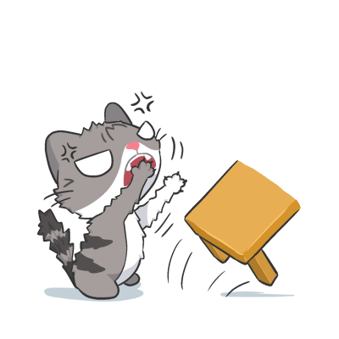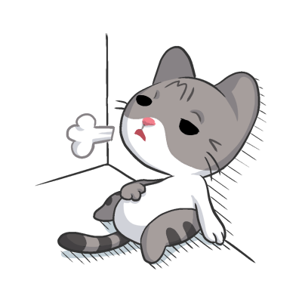
n g r y a i t r d e n e f i
________ _________ ________

- Find the words from exercise 1.
s | l | e | e | p | y
a | a | f | i | n | e
d | h | a | p | p | y
h | b | i | o | b | x
t | i | r | e | d | t
a | n | g | r | y | p

Answer key
- Sad, happy, sleepy, angry, tired, fine.

s | l | e | e | p | y
a |  | f | i | n | e
d | h | a | p | p | y
t | i | r | e | d
a | n | g | r | y

