Name: ____________________________ Surname: ____________________________ N^{ber}: ____ Grade/Class: _____
Assessment: _____________________________ | Date: ___________________________________________________
 | Teacher’s signature:  ___________________________ | Parent’s signature:  ___________________________

- Find the words.
a h a p p y g s a d b s l e e p y h a t I r e d j h a n g r y I u g r e a t k

- Label the pictures.
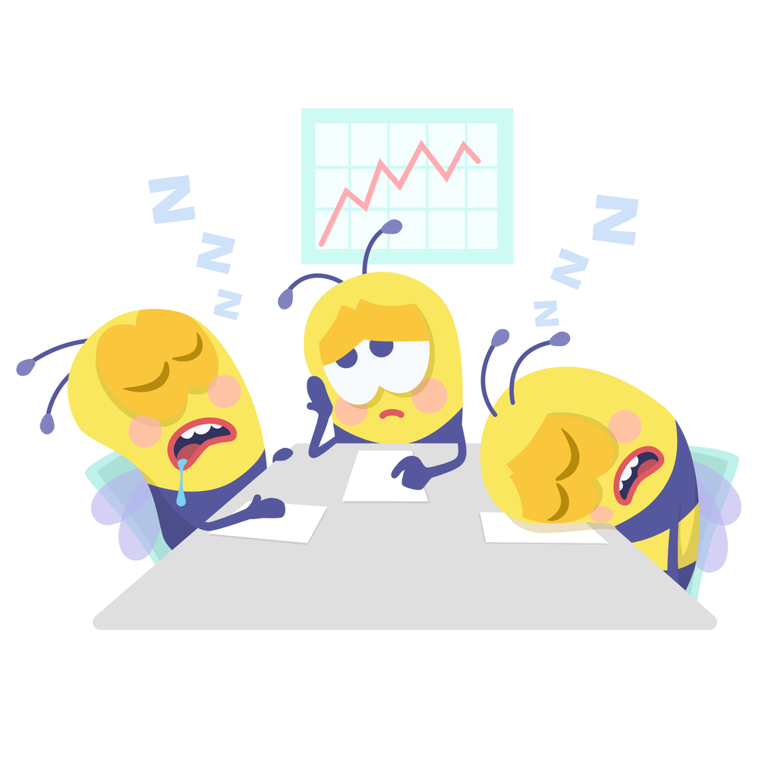

- ____________________ b) ____________________ c) ____________________
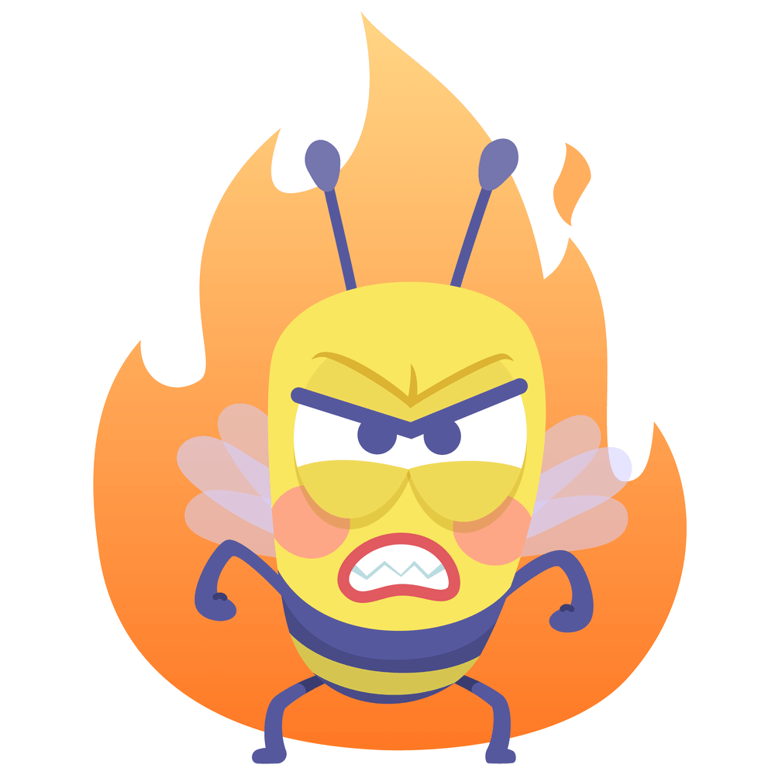
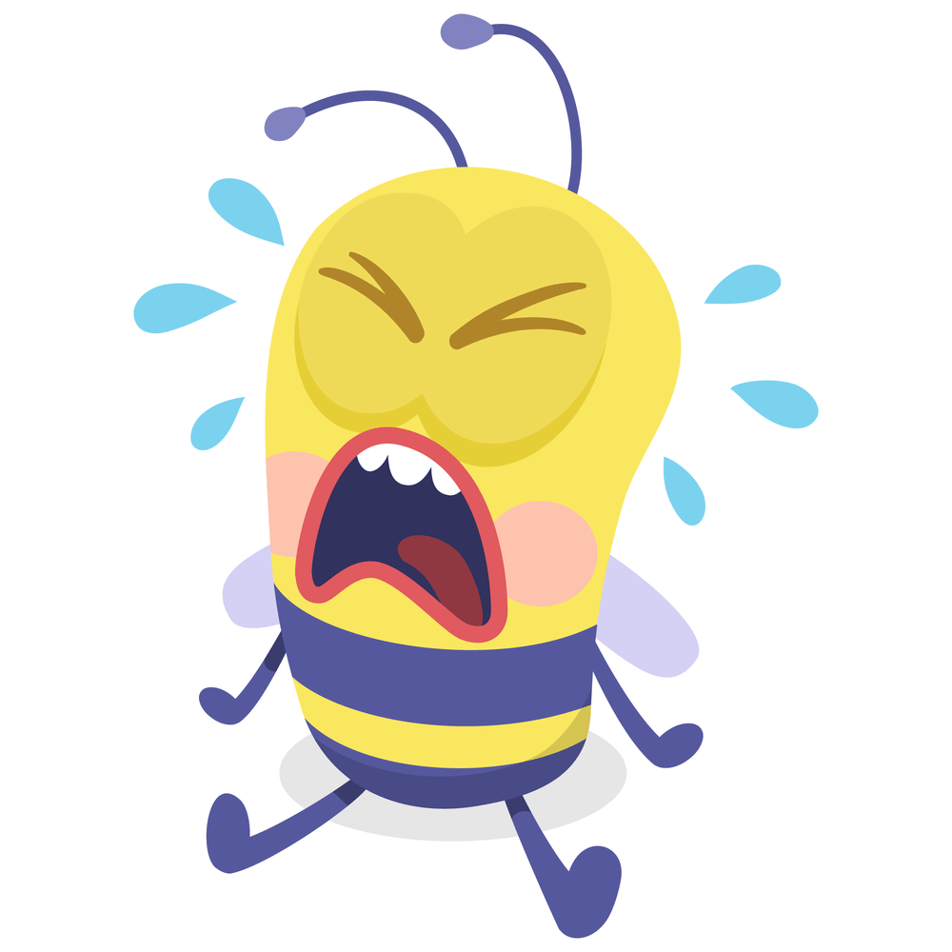

d)____________________ e) ____________________ f) ____________________

Answer key

- h a p p y s a d s l e e p y t I r e d a n g r y g r e a t

- A) tired, b) happy, c) great d) angry, e) sad f) sleepy

