Name: ____________________________ Surname: ____________________________ N^{ber}: ____ Grade/Class: _____
Assessment: _____________________________ | Date: ___________________________________________________
 | Teacher’s signature:  ___________________________ | Parent’s signature:  ___________________________

- How are they feeling? Look at the pictures and write.
He is…
They are…
She is…

…confused.
…sick.
… happy.
…silly.

a) ____________________________________ b) ____________________________________
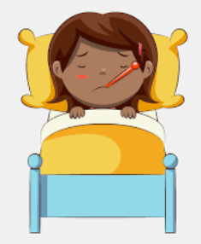
c) _____________________________________ d) _____________________________________

2) Answer the question.
a) How do you feel in the morning?____________________________________________
b) How do you feel at night? ____________________________________________
Answer key

  - He is confused
  - They are happy
  - He is silly
  - She is sick

  - I feel happy
  - I feel tired/sleepy

