Name: ____________________________ Surname: ____________________________ N^{ber}: ____ Grade/Class: _____
Assessment: _____________________________ | Date: ___________________________________________________
 | Teacher’s signature:  ___________________________ | Parent’s signature:  ___________________________

- Complete the sentences.
…excited…
…angry…
…hungry…
…thirsty…
…sad…
…cold…

a) Are you _________________________ about your holiday?
b) Is there any water? We're both ______________________.
c) I need some food. I'm ______________________.
d) My teacher is ______________________ because I'm late.
e) Her test score is low. She is ______________________.

- Look at the pictures and write.
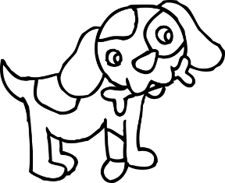
Molly Alice Alex

- Molly is _______________
- Alice is ________________
- Alex is ________________

Answer key

  - Are you excited about your holiday?
  - Is there any water? We’re both thirsty.
  - I need some food. I’m hungry.
  - My teacher is angry because I’m late.
  - Her test score is low. She is sad.

  - Molly is sad.
  - Alice is hungry.
  - Alex is angry.

