Name: ____________________________ Surname: ____________________________ N^{ber}: ____ Grade/Class: _____
Assessment: _____________________________ | Date: ___________________________________________________
 | Teacher’s signature:  ___________________________ | Parent’s signature:  ___________________________

- How do they feel? Look at the pictures and write.
…sad.
…calm.
…happy.
…shy.
I’m…
He’s…
They’re…
She’s…

a) ____________________________________ b) ____________________________________
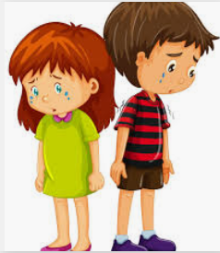
c) _____________________________________ d) _____________________________________

2) Order the words.
a) are / feeling / great / The girls / . ____________________________________________
b) today / The teacher / happy/ is / . ____________________________________________
Answer key

  - I’m shy.
  - She’s calm.
  - He’s happy.
  - They’re sad.

  - The girls are feeling great
  - The teacher is happy today.

