Name: ____________________________ Surname: ____________________________ N^{ber}: ____ Grade/Class: _____
Assessment: _____________________________ | Date: ___________________________________________________
 | Teacher’s signature:  ___________________________ | Parent’s signature:  ___________________________

- Read and match.
- He is happy.
- He is angry.
- She is worried.
- He is sad.

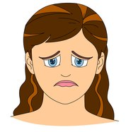

- Read and link.
It is my birthday.
They are happy.
1) A

Alex is late for school.
2) B

I am excited.

3) C

He is worried.
Susan is back from school.

4) D

She is tired.
Molly and David are at the park.

Answer key

- 4; 1; 3; 2
- 1-b; 2-c; 3-d; 4-a

