Name: ____________________________ Surname: ____________________________ N^{ber}: ____ Grade/Class: _____
Assessment: _____________________________ | Date: ___________________________________________________
 | Teacher’s signature:  ___________________________ | Parent’s signature:  ___________________________

- Read and choose the best answer. Put a tick.

- It is your birthday. You are…
sad happy angry

- You are late for school. You are…
worried happy excited

- It is raining. You are ….
happy bored angry

- You are back from school. You are…
happy tired angry

- Read. Put a tick or a cross.

- The bee is angry. b) The bee is sad.

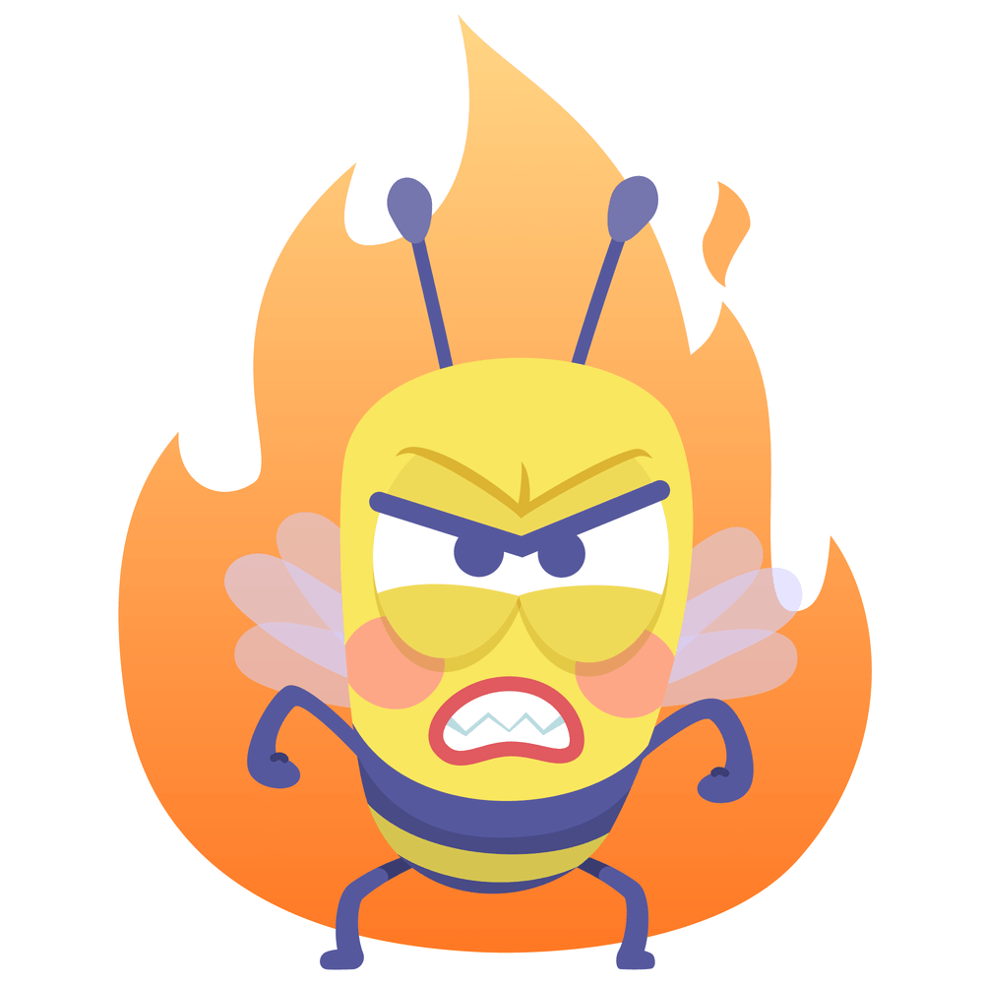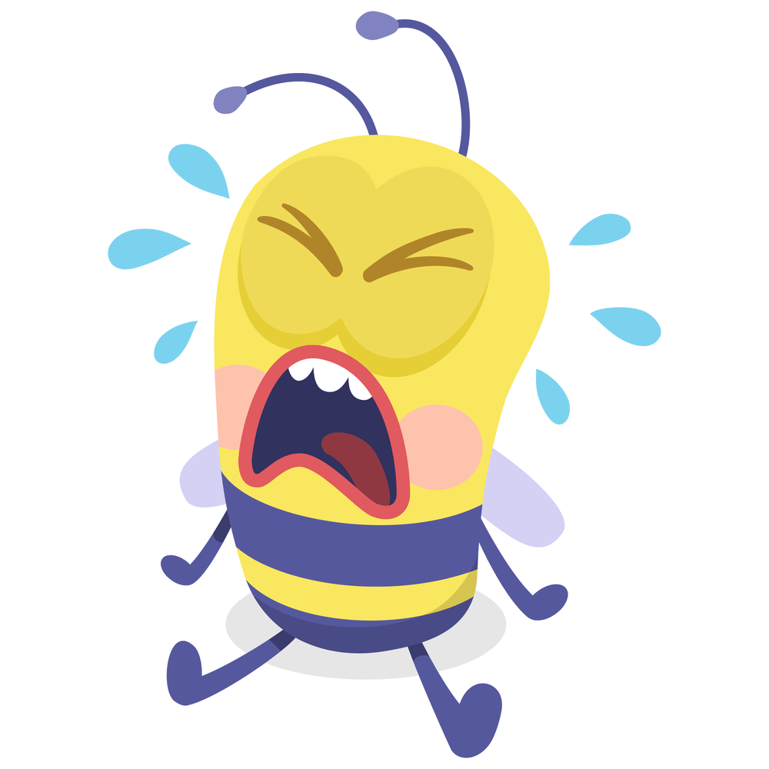

c) The bee is happy. d) The bees are tired.
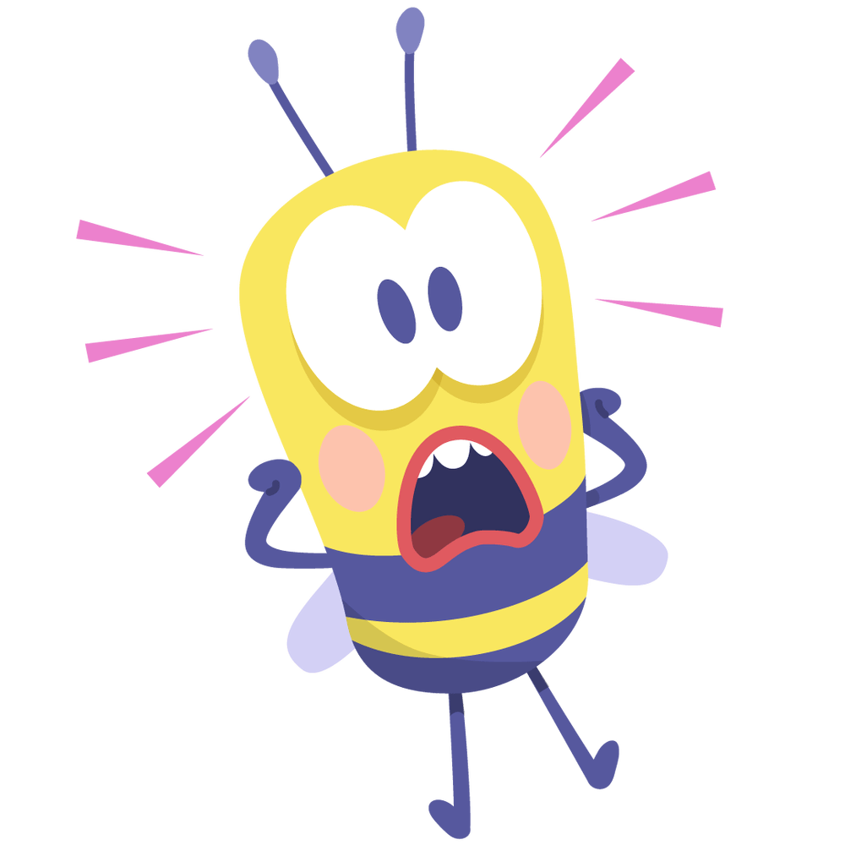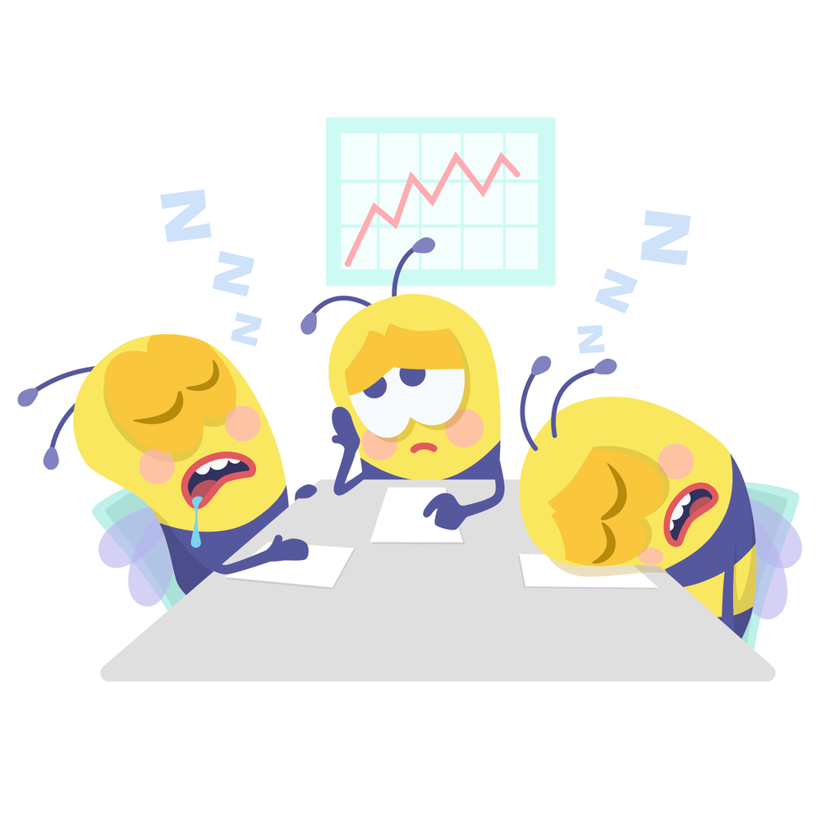
Answer key

- A) happy, b) worried, c) bored, d) angry

- A) Yes, b) yes, c) no, d) yes

