Name: ____________________________ Surname: ____________________________ N^{ber}: ____ Grade/Class: _____
Assessment: _____________________________ | Date: ___________________________________________________
 | Teacher’s signature:  ___________________________ | Parent’s signature:  ___________________________

- Read and write the names.

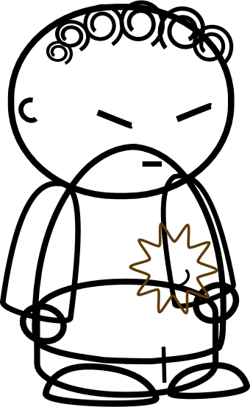
This is Eric. He is at the park. He is happy.
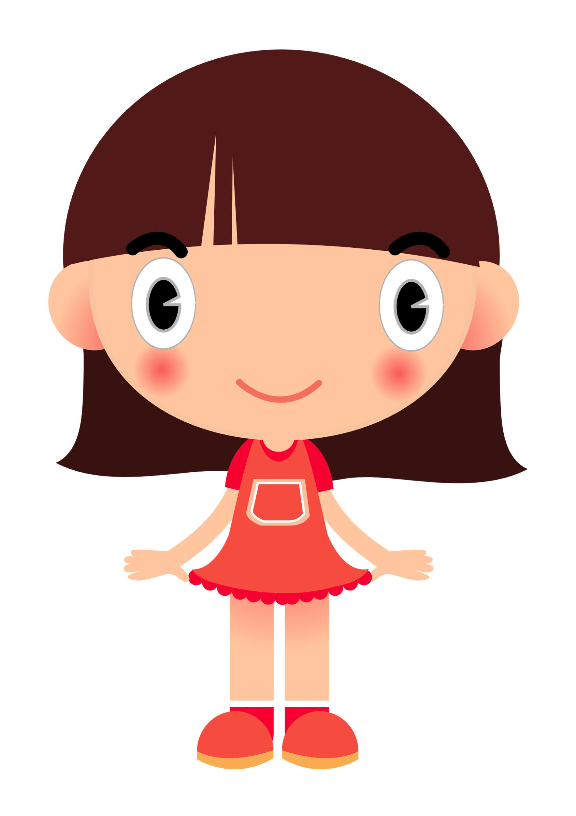
This is Amy. She is sad. She isn’t happy today.

This is Molly. It is her birthday today. She is happy.

b) ____________
d) ____________
e) ____________
a) ____________
This is Wang. He isn’t happy today. He is angry.

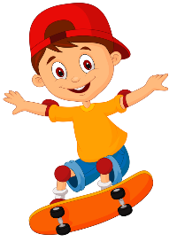
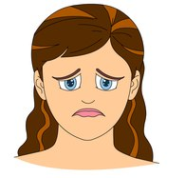

2) Read and circle.

Hello, I am Eric. I am at the park today. I am happy / sad. I am always happy / bored at the park.
I am happy / tired after school.
I am tired / bored when it
I am sad / excited at my birthday.

Answer key

- A) Wang, b) Molly, c) Amy, d) Eric

- Happy; happy; tired; bored; excited.

