Name: ____________________________ Surname: ____________________________ N^{ber}: ____ Grade/Class: _____
Assessment: _____________________________ | Date: ___________________________________________________
 | Teacher’s signature:  ___________________________ | Parent’s signature:  ___________________________

Read the text.

This is Ravi. He is happy. It is his birthday.
Eric is worried. He is late for school.
Daisy is sad. She misses her friends.
Jason is angry. There is no cartoon on TV.
Alice is excited. Jack is tired.

- Tick the ones from the text.
Ravi
Eric
Daisy
Jason
Alice
Jack

2) Read the text again and write names.
_____ _______ ________
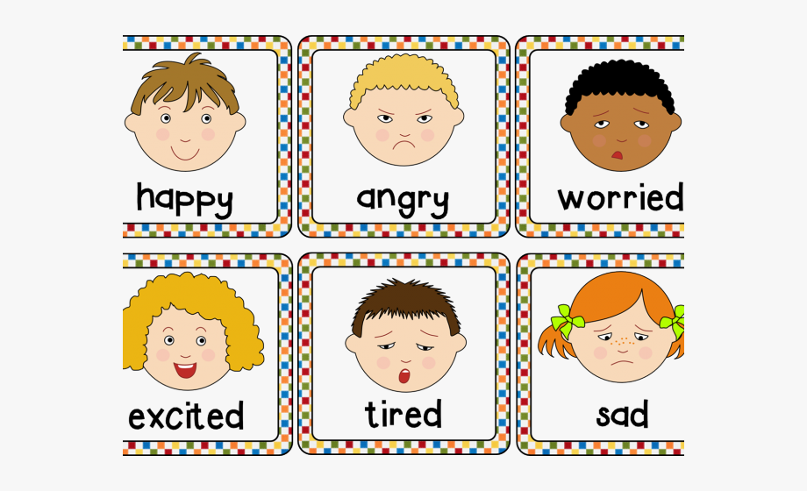

_______ _________ __________
Answer key

Ravi | X
Eric |  |  |  |  | X
Daisy |  | X
Jason |  |  |  |  |  | X
Alice |  |  |  | X
Jack |  |  | X

- Ravi; Jason; Eric; Alice; Jack; Daisy.

