Name: ____________________________ Surname: ____________________________ N^{ber}: ____ Grade/Class: _____
Assessment: _____________________________ | Date: ___________________________________________________
 | Teacher’s signature:  ___________________________ | Parent’s signature:  ___________________________

- Group activity. One student will mime the emotions and the others will try to guess the feeling. Then the students will swipe roles.

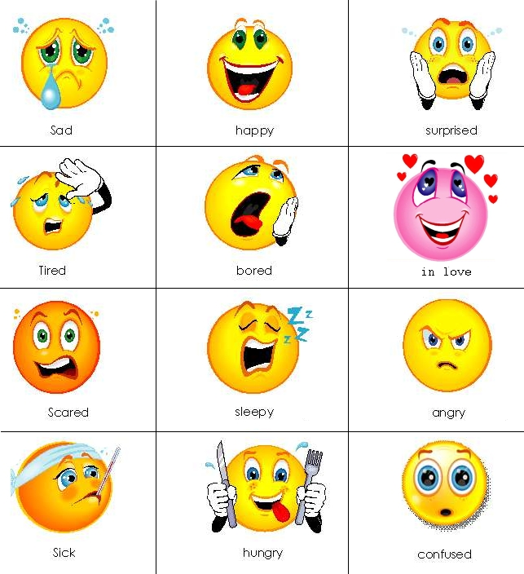

- Pair-work activity.
Practice a dialogue with your partner and then swipe roles. For example:
Student 1: How do you feel?
Student 2: I’m happy/sad/….
Student 1: Why are you …?
Student 2: I’m …… because …….
Student 1: I’m so happy/sad to hear that.

Answer key

- Mime and guess
- Depends on student’s opinion

