Name: ____________________________ Surname: ____________________________ N^{ber}: ____ Grade/Class: _____
Assessment: _____________________________ | Date: ___________________________________________________
 | Teacher’s signature:  ___________________________ | Parent’s signature:  ___________________________

Choose one emotion from the picture below and answer the questions:

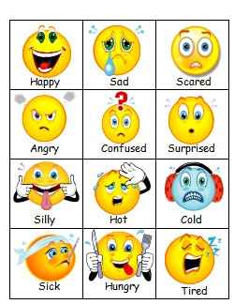

- How do you usually feel?

- When are you …… (happy/sad/angry …)

Answer key (the answers depend on the student’s feelings)

I usually feel ….
I’m ….

