Name: ____________________________ Surname: ____________________________ N^{ber}: ____ Grade/Class: _____
Assessment: _____________________________ | Date: ___________________________________________________
 | Teacher’s signature:  ___________________________ | Parent’s signature:  ___________________________

- Look and write.
Tom Ben Simba
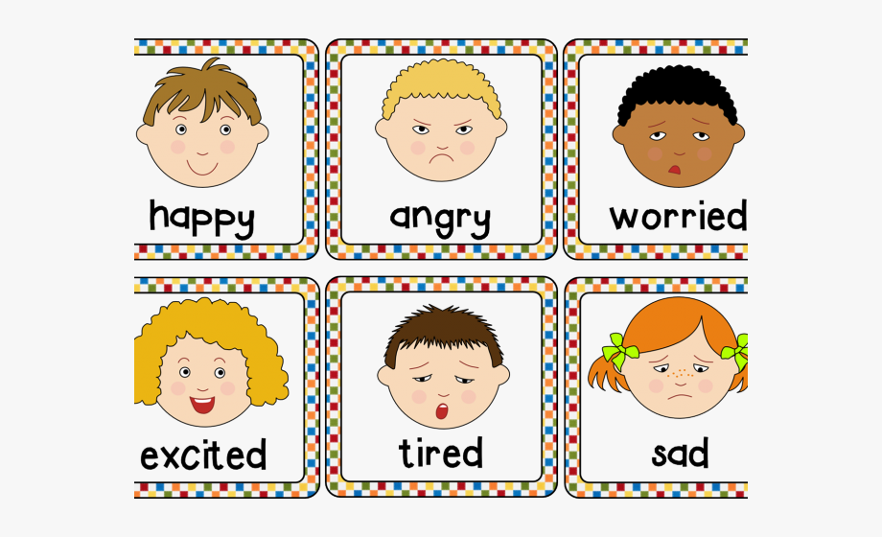
Sally Omar Lucy
- Tom is _________
- Omar is ________
- Lucy is _________
- Ben is __________

- Write answers.
- Is Omar angry? ______________
- Is Sally worried? _____________
- Is Tom happy? ______________
- Is Lucy sad? ______________

Answer key
- a) happy, b) tired, c) sad, d) angry
- a) No, he isn’t. b) No, she isn’t. c) Yes, he is. d) Yes, she is.

