Name: ____________________________ Surname: ____________________________ N^{ber}: ____ Grade/Class: _____
Assessment: _____________________________ | Date: ___________________________________________________
 | Teacher’s signature:  ___________________________ | Parent’s signature:  ___________________________

- Look at the picture and write.

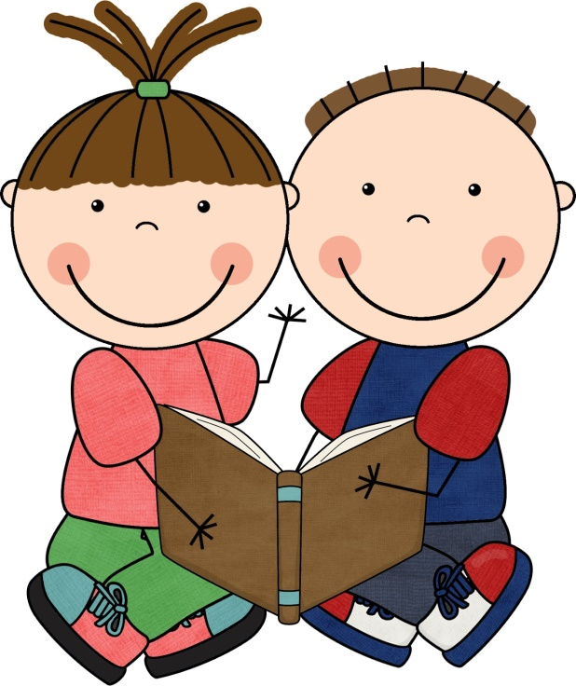

The children are ____________
The children aren’t _____________

2. Arrange the words in the correct order.

- Tom / Is / happy? _______________________________________
- angry / they / Are? _______________________________________
- does / How / he / feel? ________________________________________
- you / How / do / feel? _______________________________________

Answer key

- happy; sad
- a) Is Tom happy? b) Are they angry? c) How does he feel? d) How do you feel?

