TOPIC: Feelings | SUBTOPICS: Naming feelings | LEVEL: A1
Name: ____________________________ Surname: ____________________________ N^{ber}: ____ Grade/Class: _____

TOPIC: Feelings | SUBTOPICS: Find the Feelings | LEVEL: A1
Name: ____________________________ Surname: ____________________________ N^{ber}: ____ Grade/Class: _____
FIND THE FEELINGS
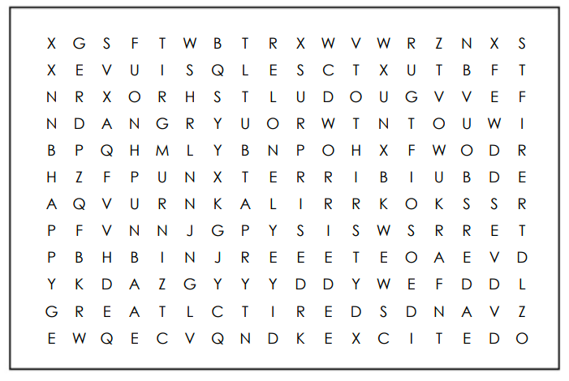
Find the following words in the puzzle. 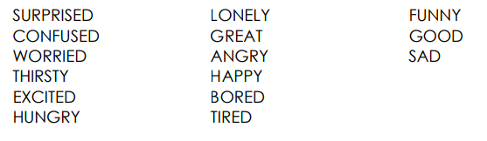

TOPIC: Feelings | SUBTOPICS: Circle the Feelings | LEVEL: A1
Name: ____________________________ Surname: ____________________________ N^{ber}: ____ Grade/Class: _____

ANSWER KEY
FIND THE FEELINGS
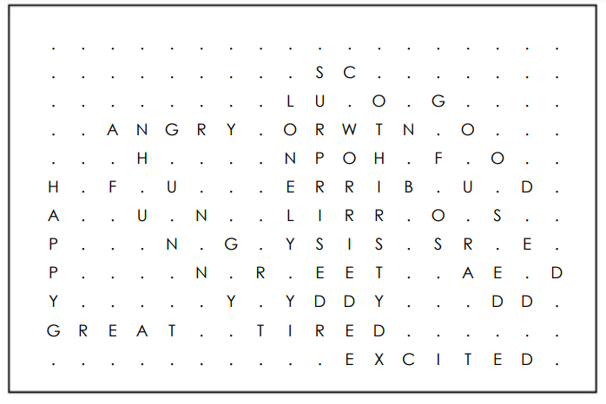
Find the following words in the puzzle.

