TOPIC: Feelings | SUBTOPICS: Circle the Feelings | LEVEL: A1
Name: ____________________________ Surname: ____________________________ N^{ber}: ____ Grade/Class: _____
CIRCLE THE FEELINGS
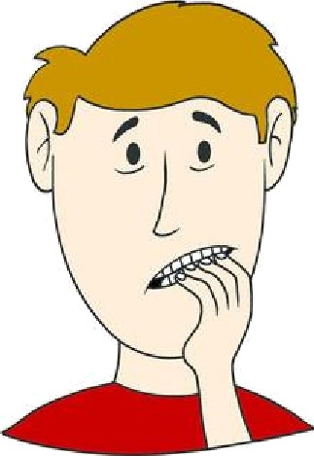
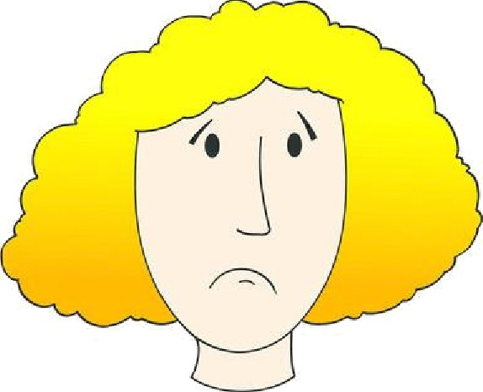
good excited angry
happy worried thirsty
excited confused sad
worried funny hungry
happy excited sad

ANSWER KEY
CIRCLE THE FEELINGS
good excited angry
happy worried thirsty
excited confused frightened
worried funny hungry
happy excited sad

