TOPIC: Feelings | SUBTOPICS: Naming feelings | LEVEL: A1
Name: ____________________________ Surname: ____________________________ N^{ber}: ____ Grade/Class: _____

MATCH THE FEELINGS

1. a. hungry

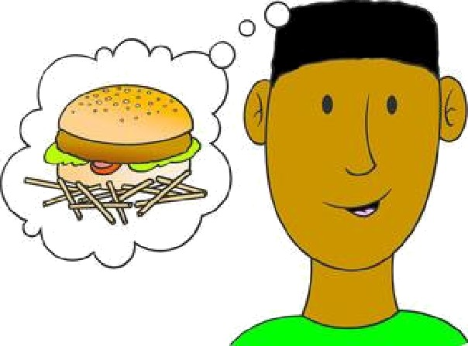
2. b. sad

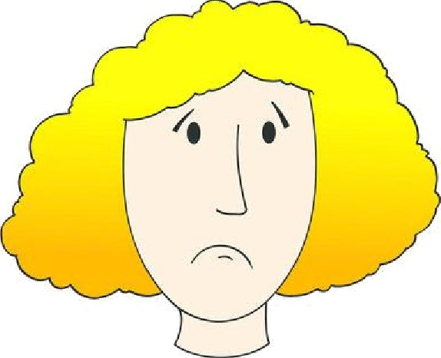
3. c. frightened

4. d. worried

5. e. angry

6. f. happy

ANSWER KEY
MATCH THE FEELINGS

1. a. hungry

2. b. sad

3. c. frightened

4. d. worried

5. e. angry

6. f. happy

