|  |  |  |
| --- | --- | --- |
| **TOPIC: Food and drinks** | **SUBTOPICS: fruit and vegetables** | **LEVEL: A1** |
| **Name:** ____________________________ **Surname:** ____________________________ **Nber: ____ Grade/Class:** _____ | | |

**Fruit or vegetables**

**Label the pictures. Then put the words in the correct column in the table below.**

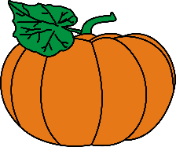

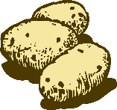

****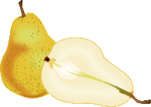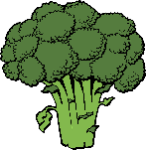

|  |  |  |  |  |
| --- | --- | --- | --- | --- |
| *11* | *13* |  |  |  |



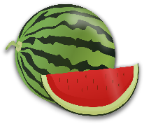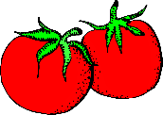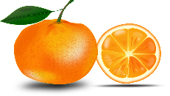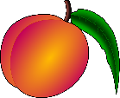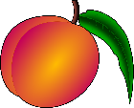

|  |  |  |  |  |
| --- | --- | --- | --- | --- |
|  |  |  |  |  |

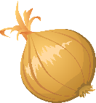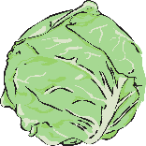

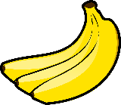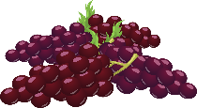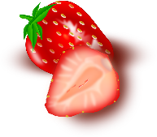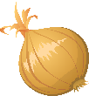

|  |  |  |  |  |
| --- | --- | --- | --- | --- |
|  |  |  |  |  |

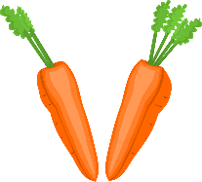

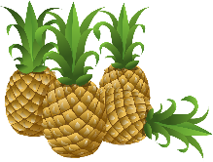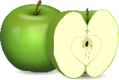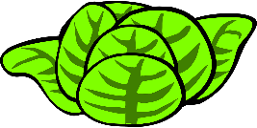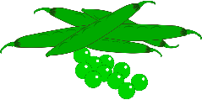

|  |  |  |  |  |
| --- | --- | --- | --- | --- |
| 1. pineapples | 2. salad | 3. watermelon | 4. pumpkin | 4. strawberries |
| 6. apples | 7. potatoes | 8. onions | 9. grapes | 10. cabbage |
| 11. ~~broccoli~~ | 12. beans | 13. ~~pears~~ | 14. peas | 15. tomatoes |
| 16. carrots | 17. peaches | 18. bananas | 19. oranges | 20. turnip |

|  |  |  |  |  |
| --- | --- | --- | --- | --- |
|  |  |  |  |  |

|  |  |
| --- | --- |
| **FRUIT** | **VEGETABLES** |
| ***pears*** | ***broccoli*** |
|  |  |
|  |  |
|  |  |
|  |  |
|  |  |
|  |  |
|  |  |
|  |  |
|  |  |