|  |  |  |
| --- | --- | --- |
| **TOPIC: Food and drinks** | **SUBTOPICS: fruit and vegetables** | **LEVEL: A1** |
| **Name:** ____________________________ **Surname:** ____________________________ **Nber: ____ Grade/Class:** _____ | | |

**Fruit and vegetables**

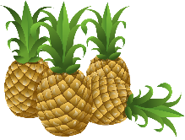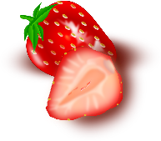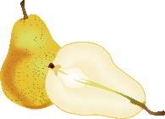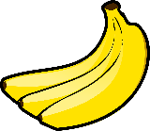**Match.**

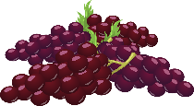

**⚫ ⚫ ⚫ ⚫ ⚫**

**⚫ ⚫ ⚫ ⚫ ⚫**

|  |  |  |  |  |
| --- | --- | --- | --- | --- |
| pineapples | bananas | pears | grapes | Strawberries |
| apples | peaches | watermelon | oranges | tomatoes |

**⚫ ⚫ ⚫ ⚫ ⚫**

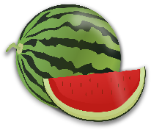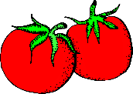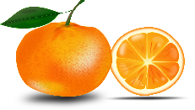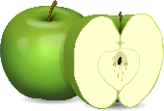 **⚫ ⚫ ⚫ ⚫ ⚫**

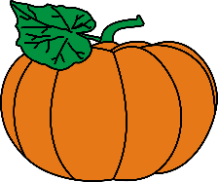

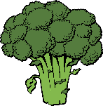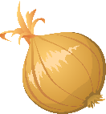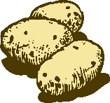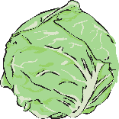

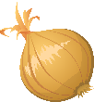

**⚫ ⚫ ⚫ ⚫ ⚫**

**⚫ ⚫ ⚫ ⚫ ⚫**

|  |  |  |  |  |
| --- | --- | --- | --- | --- |
| broccoli | potatoes | onions | pumpkin | cabbage |
| carrots | beans | salad | peas | turnip |

**⚫ ⚫ ⚫ ⚫ ⚫**

     