TOPIC: Food and drinks | SUBTOPICS: ordering food; food and drinks | LEVEL: A2
Name: ____________________________ Surname: ____________________________ N^{ber}: ____ Grade/Class: _____
At the restaurant

Read the text.

Waiter: Good afternoon, can I help you?
Jane: Yes, can I have the menu?
Waiter: Here you are.
(…)
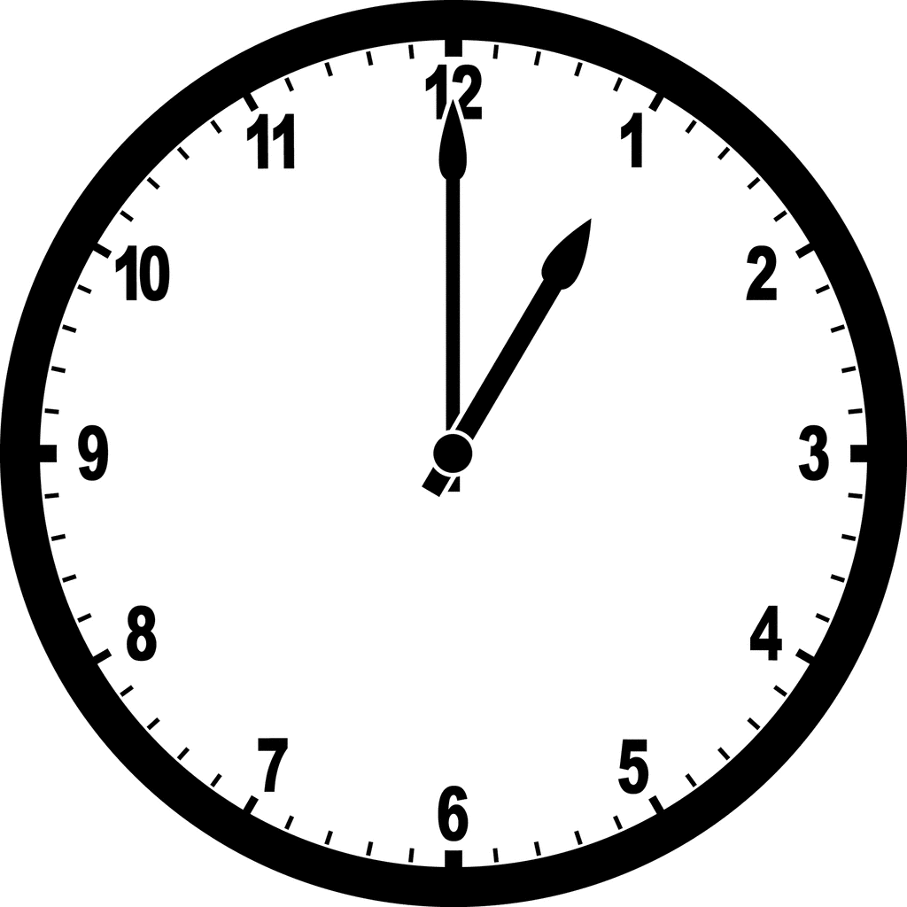
Waiter: Are you ready to order?
Jane: Yes, I’d like the beef with roast potatoes, please.
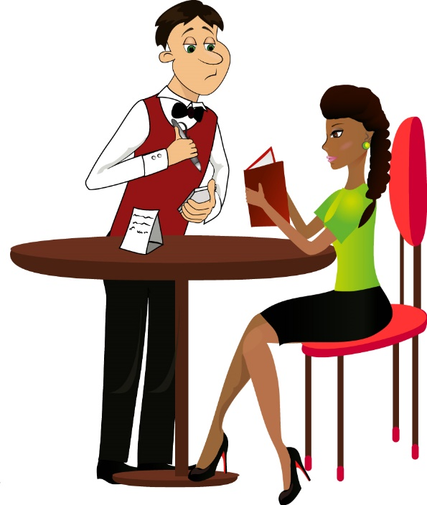
Waiter: Certainly. Would you like a starter?
Jane: a carrot soup, please.
Waiter: Ok, and to drink?
Jane: I’d like water.
Waiter: Would you like a dessert?
Jane: A chocolate cake and a coffee, please.
(…)
Jane: Can I have the bill, please?
Waiter: Of course. It’s 12 $
Jane: Here you are.
Waiter: Thank you very much. Have a nice day.
Jane: Thanks. You too.

- Circle the correct answer.

- Jane is the… waiter waitress customer
- Jane is having… breakfast lunch dinner
- Jane pays… twelve dollars twenty dollars ten dollars

- Complete the chart.

Jane’s meal
Starter
Main course
Drink
Dessert

