TOPIC: Food and drinks | SUBTOPICS: meals; food and drinks; time | LEVEL: A2
Name: ____________________________ Surname: ____________________________ N^{ber}: ____ Grade/Class: _____
Meals

Read the text.

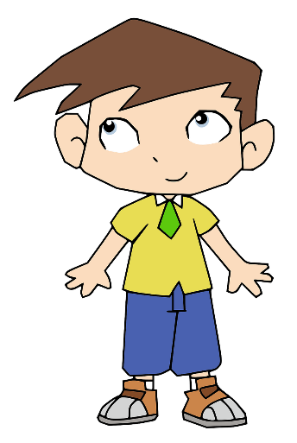
Hello! I’m Ryan. I like tea and toasts for breakfast but I don’t like milk! I have breakfast at even o´clock in the morning. I have lunch at one o´clock in the afternoon at the school canteen with my friends. My favourite lunch is pasta and sausages, then grapes. I have dinner at eight o´clock in the evening with my parents and my sister.

1. Write T (True) or F (False). Then correct the false statements
_____________________________________.
_____________________________________.
_____________________________________.
_____________________________________.
a) Ryan likes milk for breakfast.
b) He doesn’t like pasta and sausages for lunch.
c) He has dinner at eight o´clock in the evening.
d) He has dinner with his friends.

2. Answer the questions.
- He has_________________________________.
- He____________________________________.
- _______________________________________.
- _______________________________________.
a) What time does he have breakfast?
b) Where does he have lunch?
c) At lunch, what does he like for dessert?
d) Has he got brothers or sisters?

