TOPIC: Food and drinks | SUBTOPICS: food and drinks | LEVEL: A2
Name: ____________________________ Surname: ____________________________ N^{ber}: ____ Grade/Class: _____
Who am I?
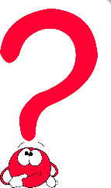
Circle the correct answer.
- I’m yellow and white. I come from chickens. I’m…
an egg a banana meat

- I’m a drink. I haven’t got any colour or smell. I’m…
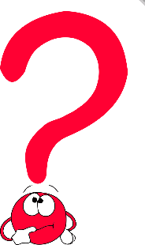
tea lemonade water

- I’m food and also an animal that lives in the water. I’m…
water a fish a penguin

- I’m a fruit and a colour, you can make juice from me. I’m…
an orange an apple a lemon

- I’m a drink. I’m white and come from cows. I’m…
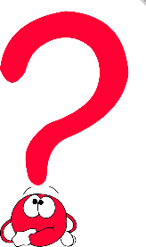
juice meat milk

- I’m yellow or white. I’m made from milk. I’m…
bread cheese milk

- You can put ham and cheese between me. I’m…
a sausage a pizza bread

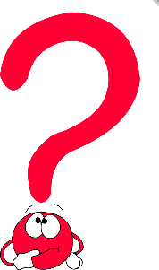
- I’m a fruit. I’m green on the outside and red on the inside. I’m…
a tomato a watermelon a potato

- I come from animals. You eat me at lunch or dinner. I’m…
meat water biscuits

10) I’m a fruit. I’ve got a yellow peeling and monkeys like me. I’m…
an apple a pineapple a banana

