TOPIC: Food and drinks | SUBTOPICS: fruit and vegetables; Do you like…? Yes, I do. / No, I don’t. | LEVEL: A2
Name: ____________________________ Surname: ____________________________ N^{ber}: ____ Grade/Class: _____
Do you like…?
Yes, I do. / No, I don’t

Write.

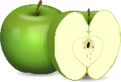

- Do you like ________________________? > Yes, I do.
- Do _______________________________? > No, I don’t.
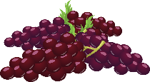
- __________________________________? > _______________.

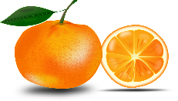
d) __________________________________? > _______________.
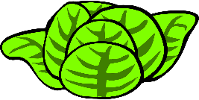
e) __________________________________? > _______________.
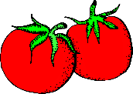
f) __________________________________? > _______________.

