TOPIC: Food and drinks | SUBTOPICS: fast food and drinks; ordering food | LEVEL: A2
Name: ____________________________ Surname: ____________________________ N^{ber}: ____ Grade/Class: _____
At the fast food restaurant

- Label the pictures.

- F_ _ n _ h f_ i _ _ | - H_ _ b _ _ g _ _ | - H_ _ d _ _ | - P_ _ z _

- C _ k _ | - I _ _ t _ _ | - I _ _ c _ e _ m

- Order the dialogue.
1
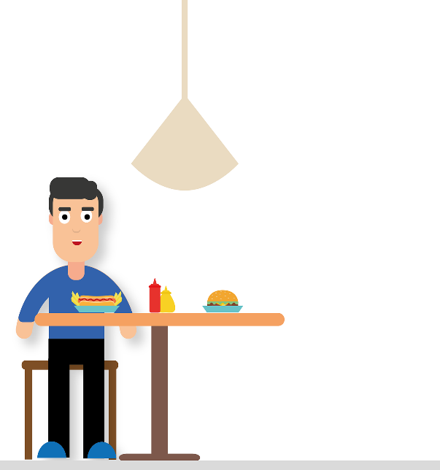
Hello, can I help you?
Fast food

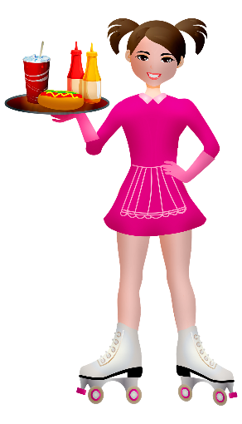
What would you like to drink?

Hello, I’d like a cheeseburger and chips.

Would you like a dessert?

A coke, please.

No, thank you.

