TOPIC: Food and drinks | SUBTOPICS: meals; food and drinks | LEVEL: A2
Name: ____________________________ Surname: ____________________________ N^{ber}: ____ Grade/Class: _____
Meals of the day

- Look and write.

Dinner Breakfast Afternoon snack Lunch

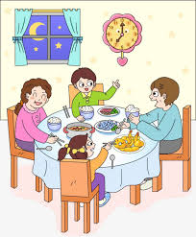
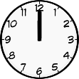
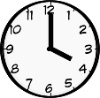
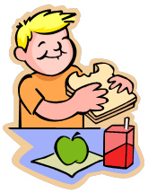
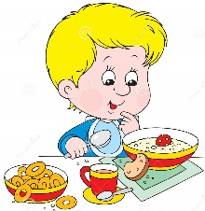
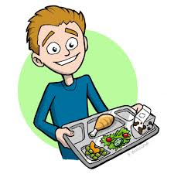
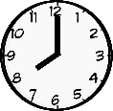

- __________________ b) _________________ c) _________________ d) _________________

2) Read and complete.

water banana fish and chips fruit salad broccoli
ice cream orange juice apple lettuce meat and rice
pasta and chicken lemonade cake grapes carrots

Fruit | Vegetables | Food | Drinks | Dessert

