TOPIC: Food and drinks | SUBTOPICS: meals; time; parts of the day; food and drinks | LEVEL: A2
Name: ____________________________ Surname: ____________________________ N^{ber}: ____ Grade/Class: _____
Meals of the day

- Match and complete.
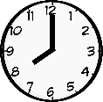
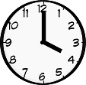
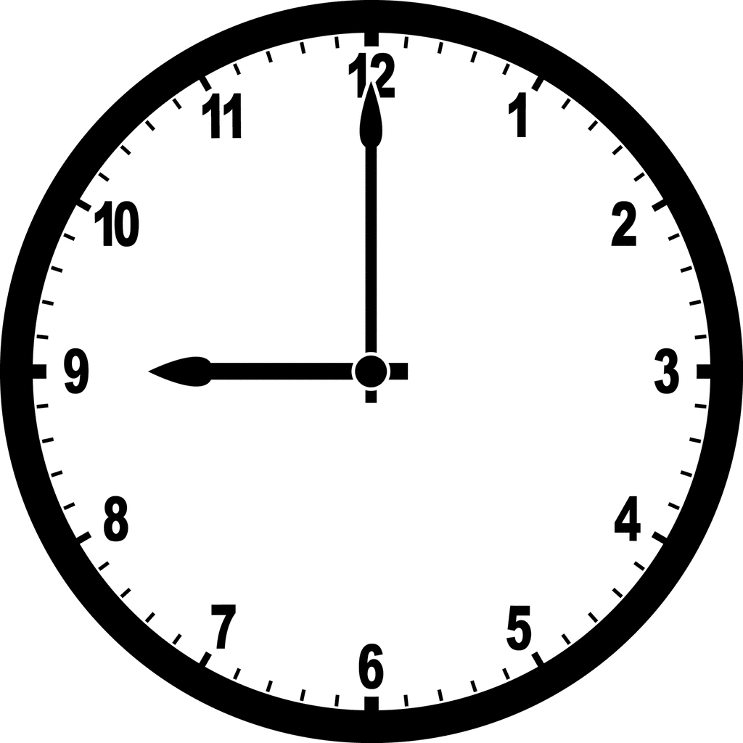
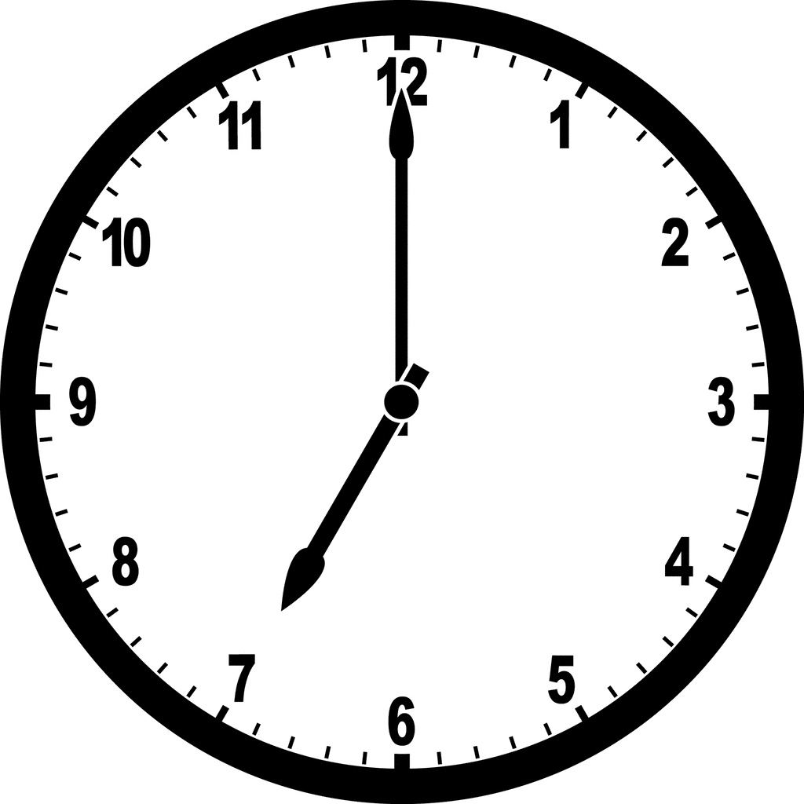
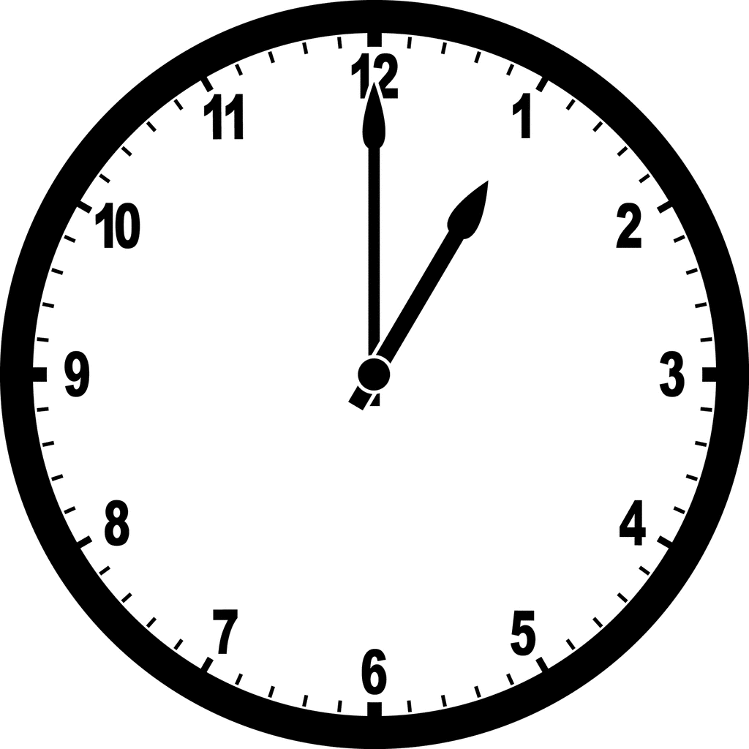
Time | Meals of the day
Eight o´clock in the morning | __ r __ __ __ f __ __ t
One o´clock in the afternoon | L __ __ __ __
Four o´clock in the afternoon | __ f __ __ __ n __ __ __ s __ __ __ k
Seven o´clock in the evening | __ i __ __ __ __
Nine o’clock in the evening | S __ __ __ __ r

- Look and write.
Hello!
I h__________ d__________ at ___________ o´clock in the _________________.
I like ____________ and ____________ .
To drink I like ___________ or __________ .
For dessert, I love _____________
