TOPIC: Food and drinks | SUBTOPICS: I like… but I don’t like… ; food and drinks | LEVEL: A2
Name: ____________________________ Surname: ____________________________ N^{ber}: ____ Grade/Class: _____
Likes and dislikes

1) Complete the sentences.
a)

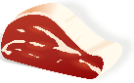
I like ______________________ but I don’t like __________________

b)

I __________________________ but I __________________________
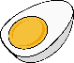

c)

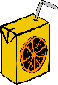
____________________________ _______________________________

d)
____________________________ _______________________________
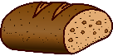
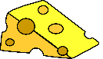

2) Read and tick.
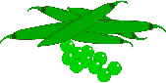
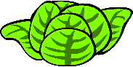
- I like lettuce but I don’t like tomatoes.
- I like pears but I don’t like grapes.
- I like carrots but I don’t like peas.
