TOPIC: Food and drinks | SUBTOPICS: meals of the day; time; food and drinks | LEVEL: A2
Name: ____________________________ Surname: ____________________________ N^{ber}: ____ Grade/Class: _____

MEALS OF THE DAY – FOOD AND DRINKS
We eat different food at different times of the day.
- Label the pictures.
- Complete the texts.
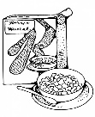
IN THE MORNING
MEAL: breakfast | TIME: at __________________________________
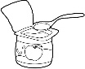

1. cereal 2. milk 3.bread 4. tea 5. toasts 6. a yogurt

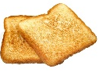
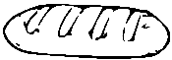

I have b_________________ at ________________________________ in the m______________.
I like __________________________________ and _____________________________ for breakfast.

IN THE AFTERNOON
MEAL: lunch | TIME: at __________________________________
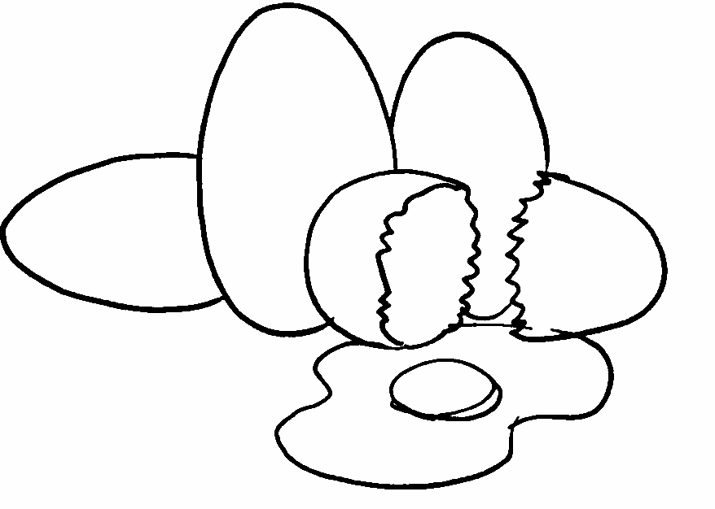
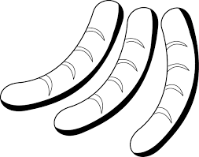

1. meat 2. fish 3. eggs 4. sausages
5. rice 6. pasta 7. spaghetti
8. potatoes 9. chips
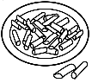
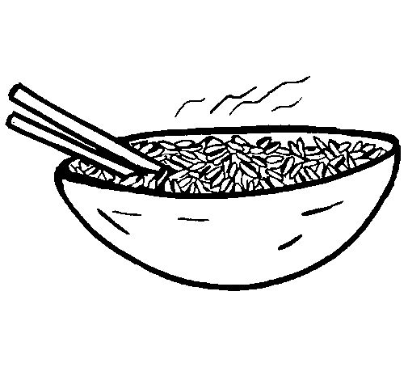
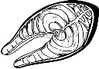

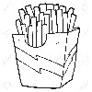
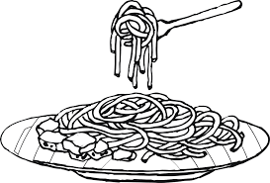

I have l____________ at ________________________________ in the a________________.
I like __________________________________ and _____________________________ for lunch.

IN THE AFTERNOON
MEAL: afternoon snack | TIME: at __________________________________
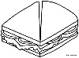
1. a sandwich 2. cake 3. biscuits
4. pizza 5. a yogurt 6. juice
7. lemonade 8. milk and cereal 9. tea

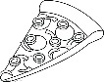

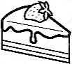
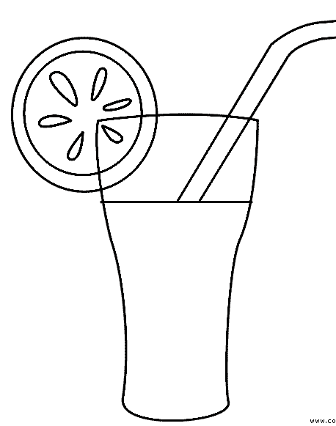
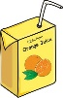

I have an a______________ s_________ at ________________________________ in the a______________.
I like _______________________________ and __________________________ for an afternoon snack.

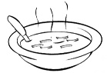
IN THE EVENING
MEAL: dinner | TIME: at __________________________________

1. meat 2. fish 3. crisps 4. soup
5. rice 6. pasta 7. spaghetti
8. potatoes 9. hamburger

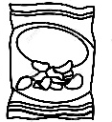
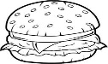

I have d_______________ at ________________________________ in the e______________.
I like __________________________________ and _____________________________ for dinner.

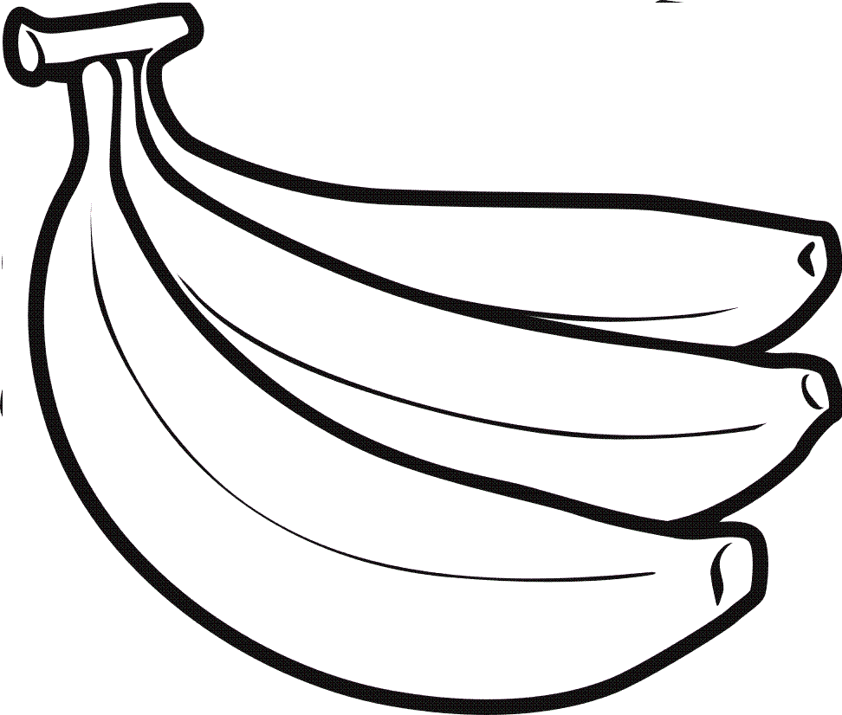
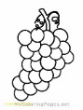
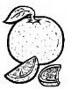
IN THE EVENING
MEAL: supper | TIME: at __________________________________
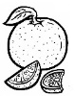
1. apples 2. pears 3. oranges
4. grapes 5. bananas

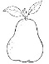
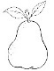
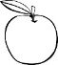
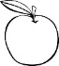

I have s_______________ at ________________________________ in the e______________.
I like __________________________________ and _____________________________ for supper.

