TOPIC: Food and drinks | SUBTOPICS: (s)he likes… and… / (s)he doesn’t like… or… ; food and drinks | LEVEL: A2
Name: ____________________________ Surname: ____________________________ N^{ber}: ____ Grade/Class: _____

Likes and dislikes

1) Write sentences about what (s)he likes or doesn’t like. Use and or or.

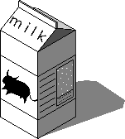
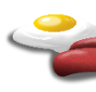
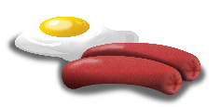
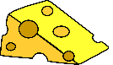
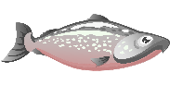

Melissa | John | Kate | Mark

- Melissa likes _____________________________________________________________________.
- ________________________________________________________________________________.
- ________________________________________________________________________________.
- ________________________________________________________________________________.

2) Order and write.

- likes / juice. / She / doesn’t / tea / but / like / she
___________________________________________________________.

- hamburger / He / but / doesn’t / he / likes / pizza. / like
___________________________________________________________.

- doesn’t / cake / she / like / biscuits. / She / likes / but
___________________________________________________________.

