Name: ____________________________ Surname: ____________________________ N^{ber}: ____ Grade/Class: _____
Assessment: _____________________________ | Date: ___________________________________________________
 | Teacher’s signature:  ___________________________ | Parent’s signature:  ___________________________

1) What they like and they don’t they like.
Listen and put a tick ( ) or a cross ( ).

 | 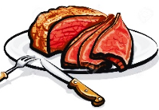 | 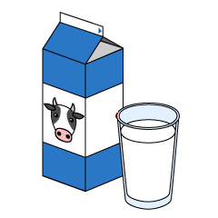 | 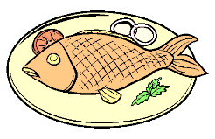 | 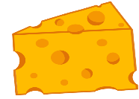 | 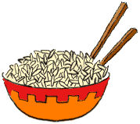
Mary
Ryan
Kate
Mike

2) Snack
Listen and number.
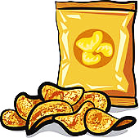
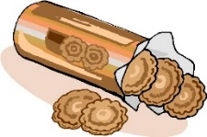
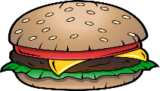

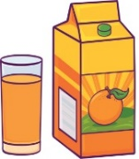
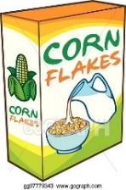

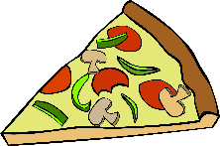
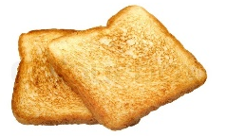

TRANSCRIPT

Exercise 1

1. Mary likes fish and water. She doesn’t like cheese.

2. Ryan likes meat and cheese. He doesn’t like rice.

3. Kate likes milk. She doesn’t like fish or water.

4. Mike likes meat and rice. She doesn’t like milk or cheese.

Exercise 2

- Yogurt
- Hamburger
- Biscuits
- Tea
- Cereal
- Crisps
- Pizza
- Juice
- Cake
- Toasts

ANSWER KEY

EXERCISE 1
MARY
- Tick: fish and water
- Cross: cheese
RYAN
- Tick: meat and cheese
- Cross: rice
KATE
- Tick: milk
- Cross: fish or water.
MIKE
- Tick: meat and rice
- Cross: milk or cheese.

EXERCISE 2
- Yogurt
- Hamburger
- Biscuits
- Tea
- Cereal
- Crisps
- Pizza
- Juice
- Cake
- Toasts

