Name: ____________________________ Surname: ____________________________ N^{ber}: ____ Grade/Class: _____
Assessment: _____________________________ | Date: ___________________________________________________
 | Teacher’s signature:  ___________________________ | Parent’s signature:  ___________________________

1) Listen and order.

2) Complete:

Time | Meal of the day
Eight o´clock in the morning | __ r __ __ __ f __ __ t
One o´clock in the afternoon | L __ __ __ __
Four o´clock in the afternoon | __ f __ __ __ n __ __ __ s __ __ __ k
Seven o´clock in the evening | __ i __ __ __ __
Nine o’clock in the evening | S __ __ __ __ r

3) Listen and number.
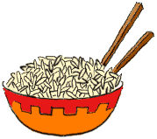
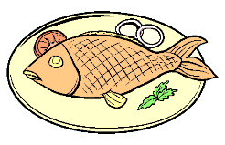
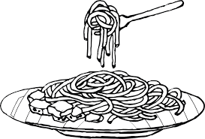

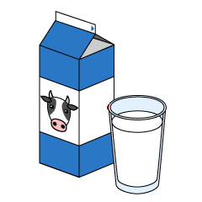
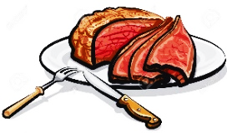

TRANSCRIPT

Exercise 1 and 2

1.
I have lunch at one o´clock in the afternoon. I like spaghetti and meat for lunch.

2.
It’s seven o´clock in the evening. It’s dinner time. I like fish and rice for dinner.

3.
I have breakfast at eight o clock in the morning. I like bread and milk for breakfast.

4.
It’s nine o clock in the evening. It’s time for supper.

5.
My favourite snack is a sandwich. At four o´clock, I have an afternoon snack.

Exercise 3

- Spaghetti
- Meat
- Fish
- Rice
- Bread
- Milk
- Sandwich

ANSWER KEY

EXERCISE 1
4 / 2 / 3 / 5 / 1

EXERCISE 2
Breakfast
Lunch
Afternoon snack
Dinner
Supper

EXERCISE 3
- Spaghetti
- Meat
- Fish
- Rice
- Bread
- Milk
- Sandwich

