Name: ____________________________ Surname: ____________________________ N^{ber}: ____ Grade/Class: _____
Assessment: _____________________________ | Date: ___________________________________________________
 | Teacher’s signature:  ___________________________ | Parent’s signature:  ___________________________

1) Listen and number.
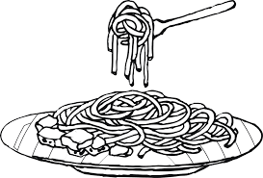
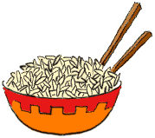
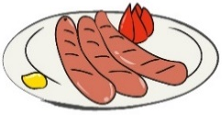
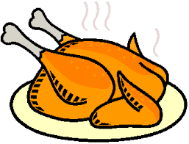

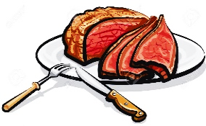
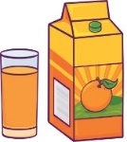
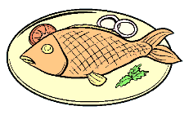

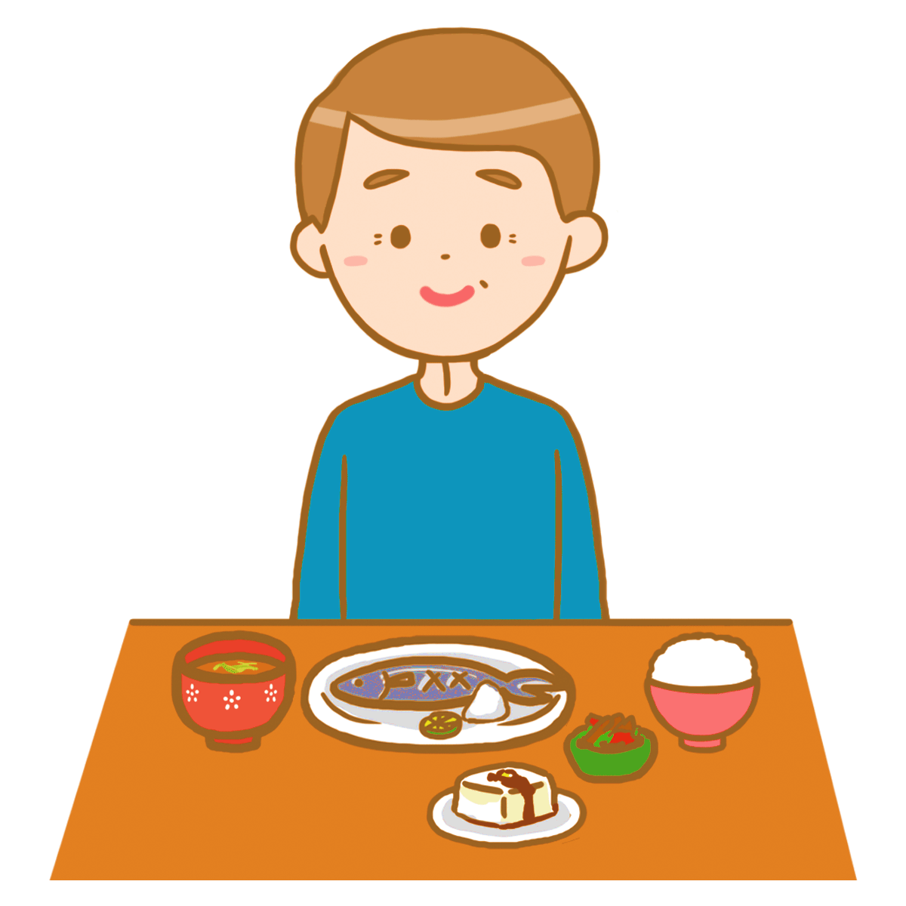
1) Listen and draw.

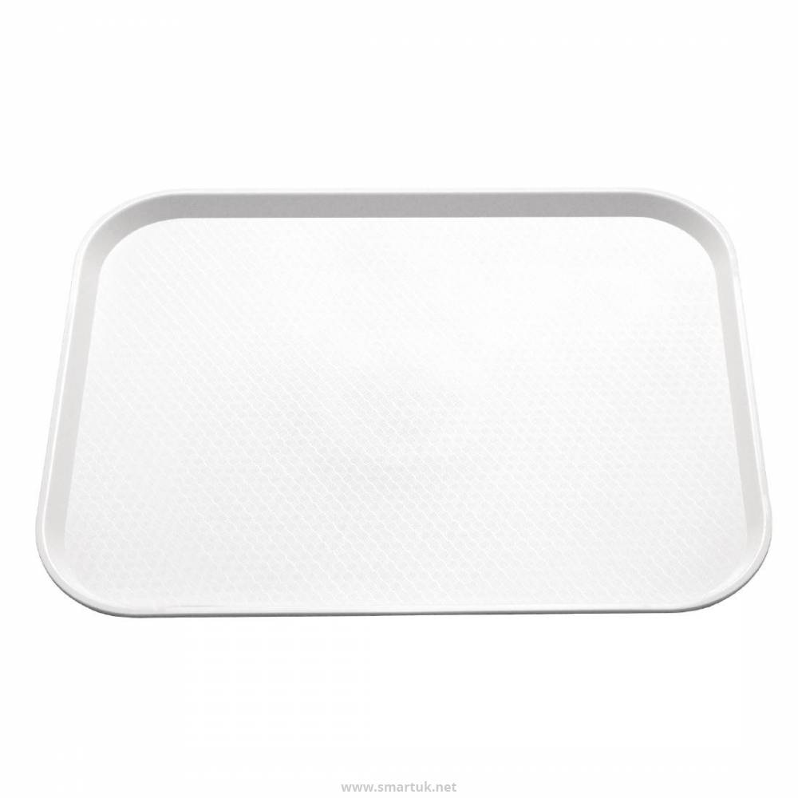

TRANSCRIPT

Exercise 1

- Fish
- Water
- Spaghetti
- Sausages
- Meat
- Juice
- Chips
- Rice
- Chicken
- Eggs

Exercise 2

It’s four o´clock. It’s time for an afternoon snack. Kevin is hungry. On his tray there is a big glass of milk, a sandwich and three biscuits. There is also a red apple. Kevin loves fruit.

ANSWER KEY

EXERCISE 1
- Fish
- Water
- Spaghetti
- Sausages
- Meat
- Juice
- Chips
- Rice
- Chicken
- Eggs

EXERCISE 2
It’s four o´clock.
On the boy’s tray: a big glass of milk, a sandwich and three biscuits, a red apple

