Name: ____________________________ Surname: ____________________________ N^{ber}: ____ Grade/Class: _____
Assessment: _____________________________ | Date: ___________________________________________________
 | Teacher’s signature:  ___________________________ | Parent’s signature:  ___________________________

Listen and tick.
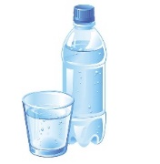
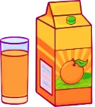
- What’s Mike’s favourite drink?
a) b) c)

- What time does Ted have breakfast?
a) b) c)

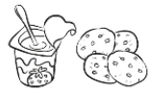
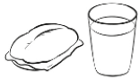
- What does Ted have for breakfast?
a) b) c)

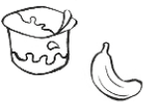
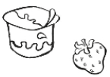
- What yogurt is the boy eating?
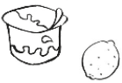
a) b) c)

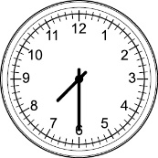
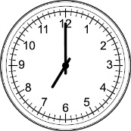
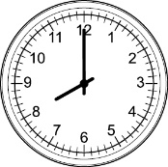
- What time does Anne have dinner?
a) b) c)

- What does Lucy like for dinner?
a) b) c)

- My favourite fruit is…
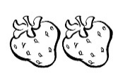
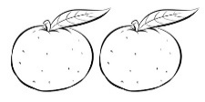
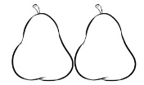
a) b) c)

TRANSCRIPT

EXERCISE 1

ONE
BOY: It’s so hot today! I’m thirsty!
GIRL: Do you like juice?
BOY: No I don’t. My favourite drink is water.
GIRL: Ok. Water. Here you are.

TWO
GIRL: What time do you have breakfast Ted?
BOY: At eight o’ clock.
GIRL: Sorry?
BOY: I have breakfast at eight o’ clock.

THREE
GIRL: Ted, what do you usually have for breakfast?
BOY: I usually have milk and cereal.

FOUR
BOY: Can I have a banana or a strawberry yoghurt, mum?
WOMAN: No, sorry. We haven’t got any. We have only got lemon yogurts.
BOY: Ok, then. I want a lemon yogurt, please.
WOMAN: Here you are.

FIVE
WOMAN: Do you have dinner at eight o’clock, Anne?
GIRL: No. I don’t. I have dinner at half past seven.

SIX
GIRL: Mum, I’m so hungry! What’s for dinner?
MOTHER: Fish, potatoes and lettuce.
GIRL: Yucky! I don’t like fish and lettuce!
MOTHER: What do you like for dinner Lucy?
GIRL: I like meat rice and carrots. Yummy, yummy!
MOTHER: Meat rice and carrots. That’s dinner for tomorrow.

SEVEN
GIRL: What’s your favourite fruit, John?
BOY: Well, I like oranges and pears, but my favourite fruit is strawberries.
GIRL: Me too. I love strawberries.

ANSWER KEY

- c
- b
- a
- c
- b
- c
- c

