Name: ____________________________ Surname: ____________________________ N^{ber}: ____ Grade/Class: _____
Assessment: _____________________________ | Date: ___________________________________________________
 | Teacher’s signature:  ___________________________ | Parent’s signature:  ___________________________

- Listen and circle True or False

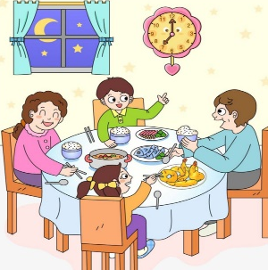
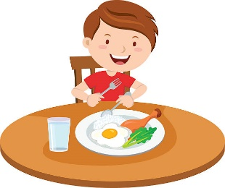
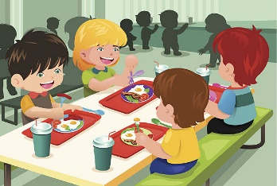
- b) c) d)

True / False
True / False
True / False
True / False

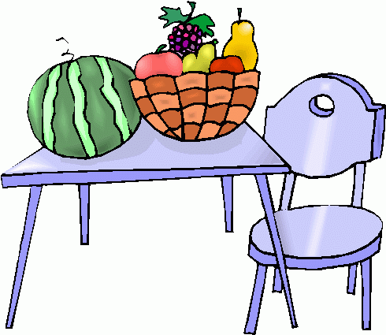
e) f) g) h)

True / False
True / False
True / False
True / False

2) Listen and draw.

a) b) c) d)

TRANSCRIPT

Exercise 1

- The children are having lunch in the school canteen.
- Emily doesn’t like vegetables.
- Paul likes eggs.
- They are having lunch.
- Peter has milk and cereal for breakfast.
- It’s very hot. They are thirsty.
- Tom is eating healthy food.
- There are fruits under the table.

Exercise 2

- - Excuse-me, what time is it? - It’s two o´clock.
- - Excuse-me, what time is it? - It’s half past nine.
- - Excuse-me, what time is it? - It’s six o clock.
- - Excuse-me, what time is it? - It’s half past two.

ANSWER KEY

EXERCISE 1
- True
- False
- True
- False
- True
- True
- False
- False

EXERCISE 2
- - It’s two o´clock.
- - It’s half past nine.
- - It’s six o clock.
- - It’s half past two.

