Name: ____________________________ Surname: ____________________________ N^{ber}: ____ Grade/Class: _____
Assessment: _____________________________ | Date: ___________________________________________________
 | Teacher’s signature:  ___________________________ | Parent’s signature:  ___________________________

- Read and reorder the dialogue.
Fast food restaurant
1
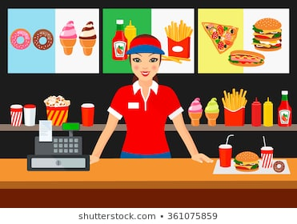
Hello, can I help you?

What would you like to drink?

Hello, I’d like a hamburger and chips.

Would you like a dessert?

Juice, please.

A chocolate ice cream.

2) Draw and label what he eats.

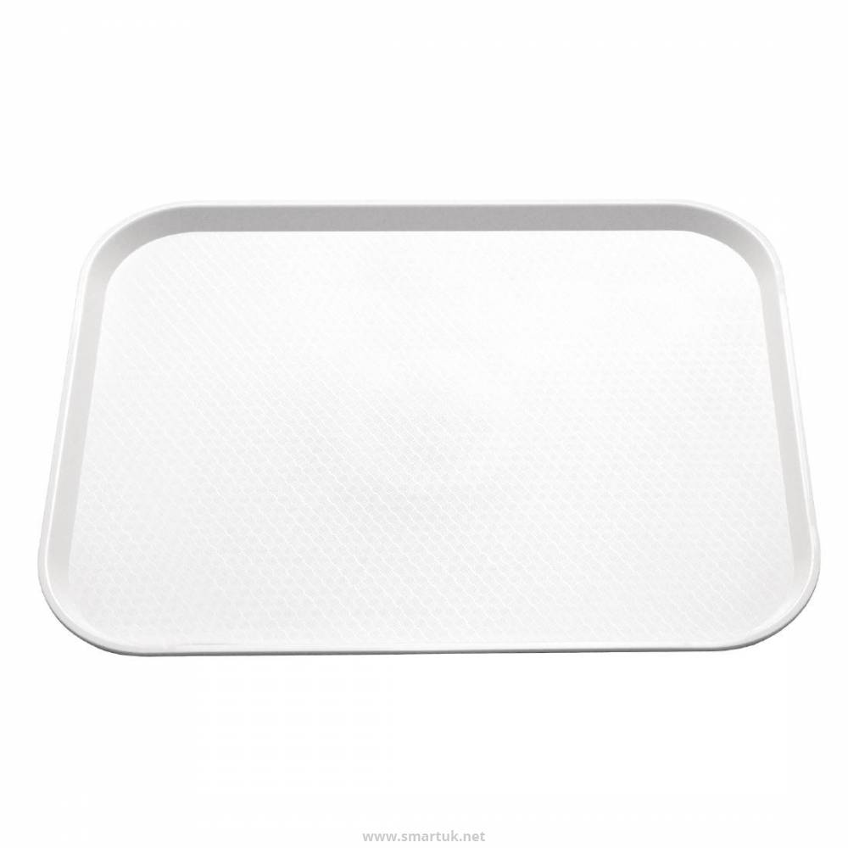

ANSWER KEY

EXERCISE 1
1
Hello, can I help you?
3
What would you like to drink?
2
Hello, I’d like a hamburger and chips.
5
Would you like a dessert?
4
Juice, please.
6
A chocolate ice cream.

EXERCISE 2
hamburger and chips
juice
chocolate ice cream.

