Name: ____________________________ Surname: ____________________________ N^{ber}: ____ Grade/Class: _____
Assessment: _____________________________  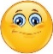  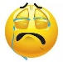 | Date: ___________________________________________________
 | Teacher’s signature:  ___________________________ | Parent’s signature:  ___________________________

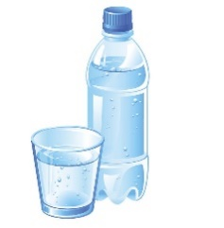
Read write and match.

- I’m yellow and white. I come from chickens.
____________________

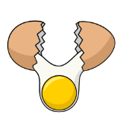
- I’m food and also an animal that lives in the water.
____________________

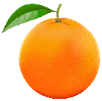
- I’m a drink. I’m white and come from cows.
____________________

- I’m yellow and white. I’m made from milk.
____________________

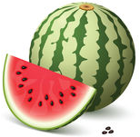

- I’m a drink. I haven’t got any colour or smell.
____________________

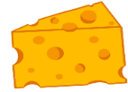
- I’m a fruit and a colour. You can make juice from me.
____________________

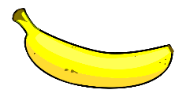

- I’m a fruit. I’ve got a yellow peel and monkeys love to eat me.
____________________

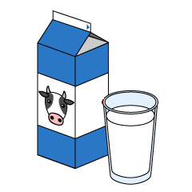

- I’m a fruit, I’m green on the outside and red on the inside.
____________________

ANSWER KEY

- Egg
- Fish
- Milk
- Cheese
- Water
- Orange
- Banana
- Watermelon

