Name: ____________________________ Surname: ____________________________ N^{ber}: ____ Grade/Class: _____
Assessment: _____________________________ | Date: ___________________________________________________
 | Teacher’s signature:  ___________________________ | Parent’s signature:  ___________________________

- Look at the picture.

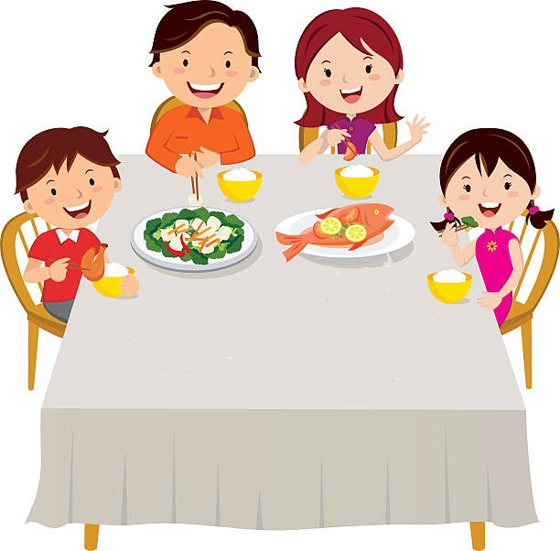

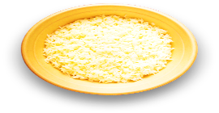

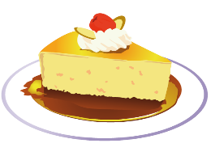
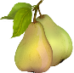
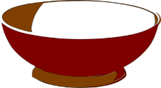

- Write Yes or No.

- It’s eight o´clock in the morning. ______
- There are two children and their parents. _______
- They are having lunch. _______
- They are in the living room. _______
- The drink is water. _______
- They are eating rice and meat. _______
- There is a pineapple near the boy. _______
- For dessert there is cake. _______
- There aren’t bananas. ______

ANSWER KEY

EXERCISE 2
- No
- Yes
- No
- No
- Yes
- No
- Yes
- Yes
- No

