Name: ____________________________ Surname: ____________________________ N^{ber}: ____ Grade/Class: _____
Assessment: _____________________________ | Date: ___________________________________________________
 | Teacher’s signature:  ___________________________ | Parent’s signature:  ___________________________

Find the 10 differences.

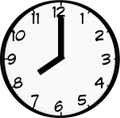

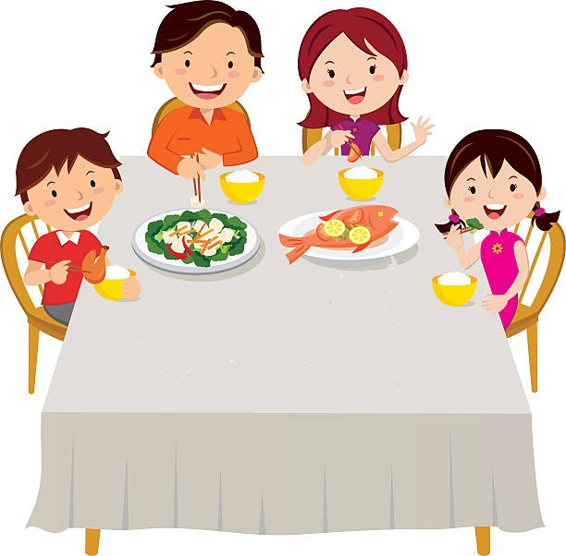

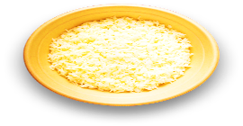

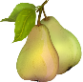
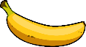
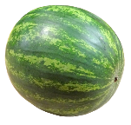
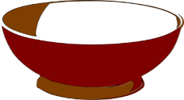
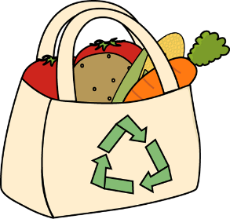

Name: ____________________________ Surname: ____________________________ N^{ber}: ____ Grade/Class: _____
Assessment: _____________________________ | Date: ___________________________________________________
 | Teacher’s signature:  ___________________________ | Parent’s signature:  ___________________________

Find the 10 differences.

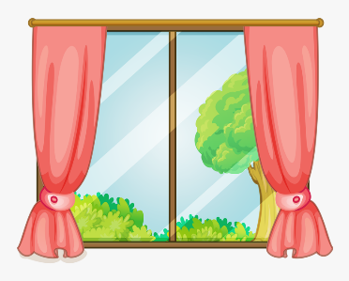
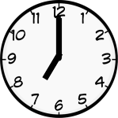

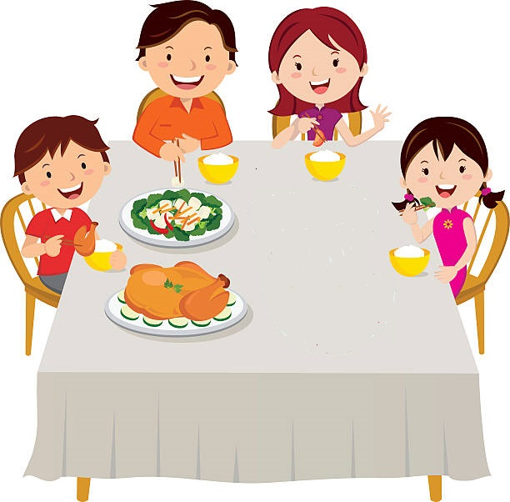

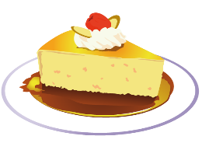

KEY ANSWER

 | PICTURE 1 | PICTURE 2
1 | Window: night | Window: day
2 | Clock: eight o’ clock | Clock: seven o’ clock
3 | A plastic bottle next to the mother | A glass bottle next to the mother
4 | No bananas on the sink | Bananas on the sink
5 | A bag with vegetables on the floor | A plastic bottle on the floor
6 | A watermelon behind the boy | A pineapple behind the boy
7 | Fish on the table | Chicken on the table
8 | No vegetables | A plate with vegetables
9 | Dessert: fruit | Dessert: cake
10 | Rice on the left side of the table | Rice on the right side of the table

