Name: ____________________________ Surname: ____________________________ N^{ber}: ____ Grade/Class: _____
Assessment: _____________________________ | Date: ___________________________________________________
 | Teacher’s signature:  ___________________________ | Parent’s signature:  ___________________________

Look at the picture.
Answer the questions.

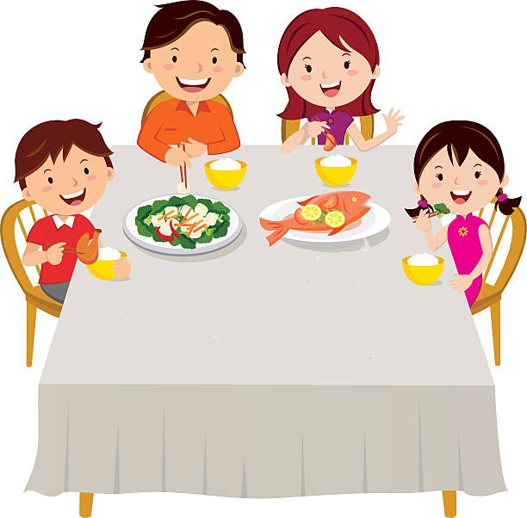

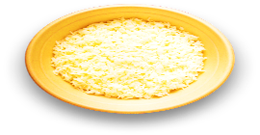

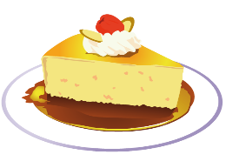
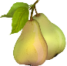
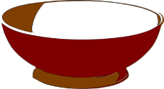

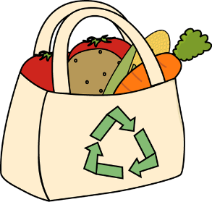

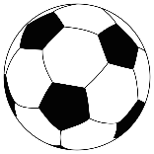

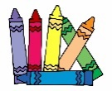
TEACHER’S QUESTIONS:

- What time is it?
- What are they doing?
- Where are they?
- How many children are there?
- What are they eating? drinking? having for dessert?
- What is in the bag?
- What is the baby doing?

KEY ANSWER

- It’s seven o’ clock in the evening.
- They are having dinner.
- They are in the kitchen.
- There are three children.
- They are eating rice and fish, they are drinking water and, for dessert, there is fruit (bananas, grapes, pears) and cake.
- There are vegetables in the bag: carrots, potatoes, tomatoes…
- The baby is playing on the floor.

