Name: ____________________________ Surname: ____________________________ N^{ber}: ____ Grade/Class: _____
Assessment: _____________________________ | Date: ___________________________________________________
 | Teacher’s signature:  ___________________________ | Parent’s signature:  ___________________________

STUDENT A

- Ask your partner what he likes for lunch or dinner (food, drink and dessert). Circle.

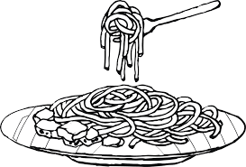
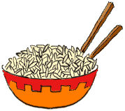
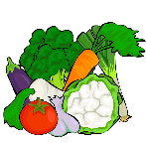
For lunch
or dinner,
…

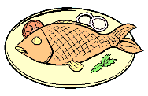
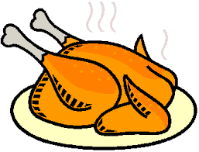
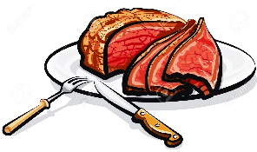
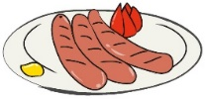

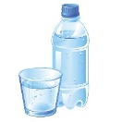
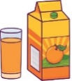
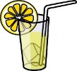
To drink,

…

For dessert,
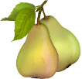
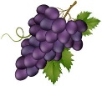
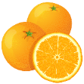
…

- Answer your partner´s questions.

- Tell your teacher/another student what (s)he likes.

For lunch or dinner, (s)he likes…
To drink, (s)he…
For dessert, (s)he…
Name: ____________________________ Surname: ____________________________ N^{ber}: ____ Grade/Class: _____
Assessment: _____________________________ | Date: ___________________________________________________
 | Teacher’s signature:  ___________________________ | Parent’s signature:  ___________________________

STUDENT B

- Ask your partner what he likes for lunch or dinner (food, drink and dessert). Circle.

For lunch
or dinner,
…

To drink,

…

For dessert,
…

- Answer your partner´s questions.

- Tell your teacher/another student what (s)he likes.

For lunch or dinner, (s)he likes…
To drink, (s)he…
For dessert, (s)he…
KEY ANSWER

Exercises 1 and 2
- What do you like for lunch / dinner?
- I like chicken and rice.
- What is your favourite drink?
- I like juice or water.
- And, for dessert, what do you like?
- I like fruit, for example, an apple or a pear.

Exercise 3
For lunch / dinner (s)he likes chicken and rice. To drink (s)he likes juice or water and, for dessert, (s)he likes fruit, for example an apple or a pear.

