Name: ____________________________ Surname: ____________________________ N^{ber}: ____ Grade/Class: _____
Assessment: _____________________________ | Date: ___________________________________________________
 | Teacher’s signature:  ___________________________ | Parent’s signature:  ___________________________

STUDENT A

- Look at the pictures and ask your partner:

 | What time do you have…? | What do you like for…?
Breakfast | 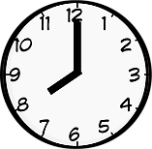  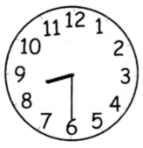 | 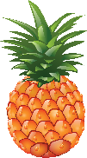  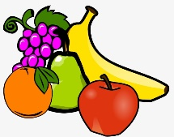  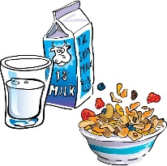  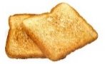  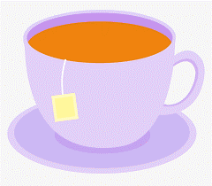  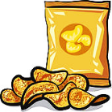  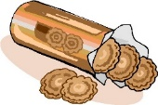  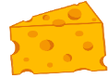  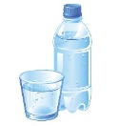  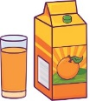
Lunch | 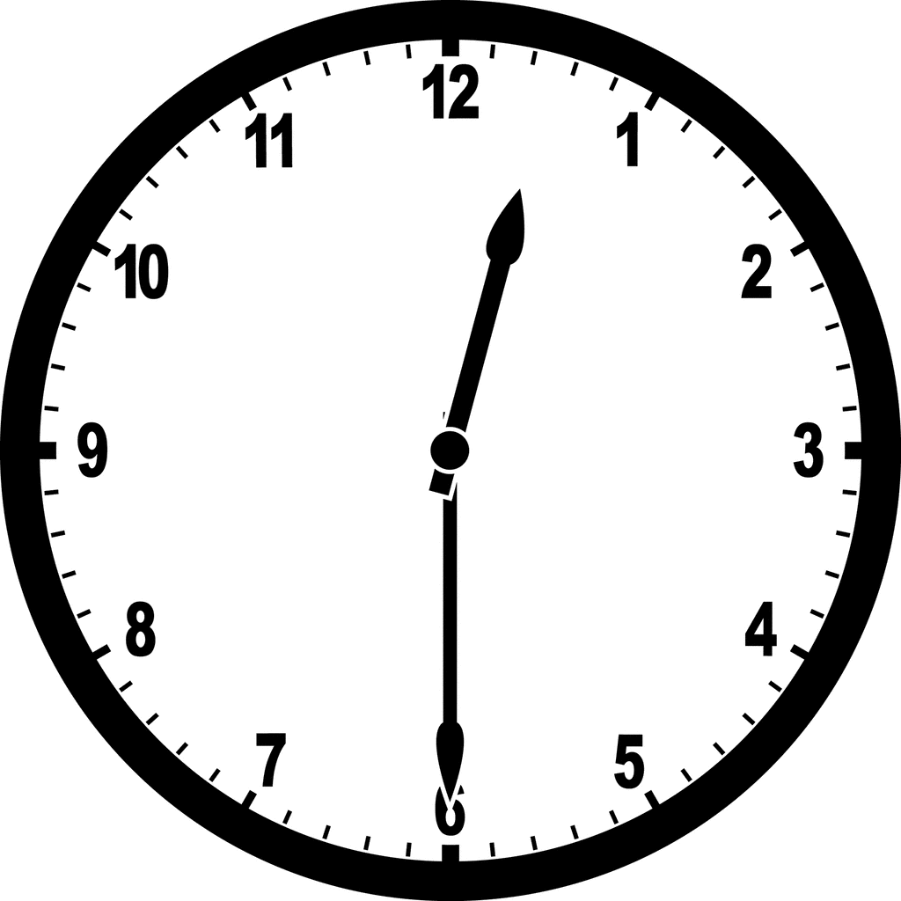  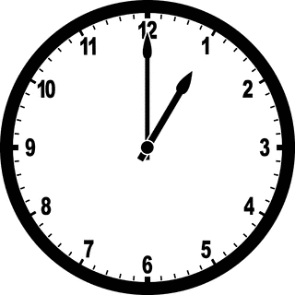 | 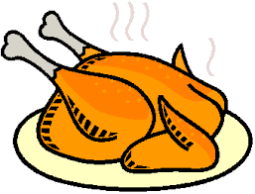  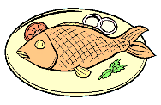  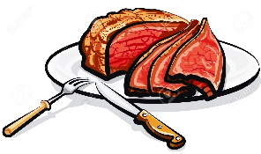  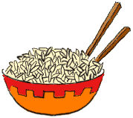  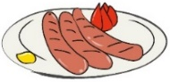  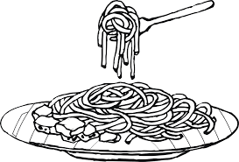  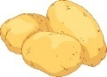

- Answer your partner’s questions.

Name: ____________________________ Surname: ____________________________ N^{ber}: ____ Grade/Class: _____
Assessment: _____________________________ | Date: ___________________________________________________
 | Teacher’s signature:  ___________________________ | Parent’s signature:  ___________________________

STUDENT B

- Look and ask your partner:

 | What time do you have…? | What do you like for…?
afternoon snack | 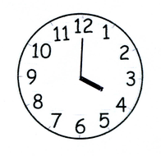  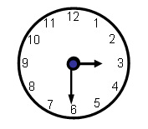
Dinner | 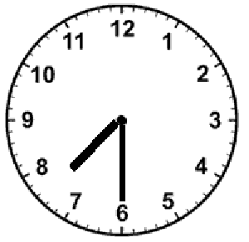  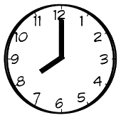

- Answer your partner’s questions.

KEY ANSWER

- What time do you have breakfast / an afternoon snack?
- I have breakfast at eight o’clock in the morning / … an afternoon snack at four o’ clock in the afternoon.
- What do you like for breakfast / an afternoon snack?
- I like milk and toasts.

- What time do you have lunch / dinner?
- I have lunch at one o’ clock in the afternoon/ … dinner at eight o’ clock in the evening.
- What do you like for lunch / dinner?
- I like fish and potatoes.

