Name: ____________________________ Surname: ____________________________ N^{ber}: ____ Grade/Class: _____
Assessment: _____________________________ | Date: ___________________________________________________
 | Teacher’s signature:  ___________________________ | Parent’s signature:  ___________________________

1) Look, complete the question and answer.
Yes / No He / She
does / doesn’t

a)
Does she like c__ __ __ __ __ __ ?
_______ , ______ ___________.
, .
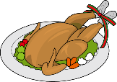

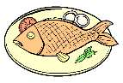
b)
Does he like f__ __ __ ?
_______ , ______ ___________.
, .

c)
Does he like h__ __ __ __ __ __ __ __?
_______ , ______ ___________.
, .

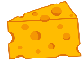
d)
Does she like c__ __ __ __ __ ?
_______ , ______ ___________.
, .

e)
_______ , ______ ___________.
, .
Does she like c__ __ __ ?

f)
Does she like r__ __ __?
_______ , ______ ___________.
, .

2) And you?
a)
Do you like spaghetti?
______ , _____ ______.
______ , _____ ______.

Do you like lemonade?
b)

ANSWER KEY
EXERCISE 1
- Does she like chicken? Yes, she does.
- Does he like fish? No, he doesn’t.
- Does he like hamburger? Yes, he does.
- Does she like cheese? No, she doesn’t.
- Does she like cake? No, she doesn’t.
- Does she like rice? Yes, she does.

EXERCISE 2
- Yes, I do. / No, I don’t.
- Yes, I do. / No, I don’t.

