Name: ____________________________ Surname: ____________________________ N^{ber}: ____ Grade/Class: _____
Assessment: _____________________________ | Date: ___________________________________________________
 | Teacher’s signature:  ___________________________ | Parent’s signature:  ___________________________
1) Circle the correct option and write.
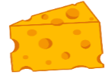
a)
She likes / doesn’t like b__ e __ __ and c__ __ __ s __.

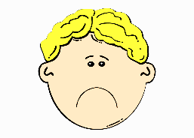
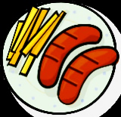
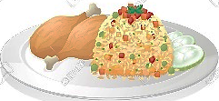
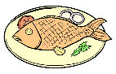
b)
He likes / doesn’t like c__ i __ s or s__ __s__ g __s.

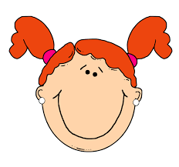
c)
She likes / doesn’t like r__ c __ and c__ i __ k __ __.

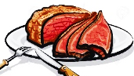
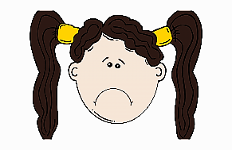
d)
She likes / doesn’t like m__ __ t or f__ __h.

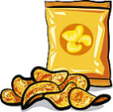
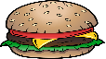
e)
He likes / doesn’t like m__ __k or c__r__ __ l.

He likes / doesn’t like __r__ s__ s and h__ __ b __ __ g __r.

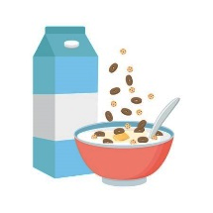
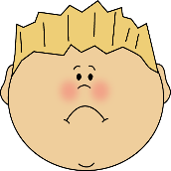
f)

2) And you?
a)
I ___________ ______________ and ______________
What food do you like?
What food don’t you like?
b)
I ___________ ______________ or ______________

ANSWER KEY
EXERCISE 1
- She likes bread and cheese.
- He doesn’t like chips or sausages.
- She likes rice and chicken.
- She doesn’t like meat or fish.
- He likes crisps and hamburger.
- He doesn’t like milk or cereal.

EXERCISE 2
Suggestion:
I like pasta and meat
I don’t like potatoes and fish.

