Name: ____________________________ Surname: ____________________________ N^{ber}: ____ Grade/Class: _____
Assessment: _____________________________ | Date: ___________________________________________________
 | Teacher’s signature:  ___________________________ | Parent’s signature:  ___________________________

1) Look and unscramble.

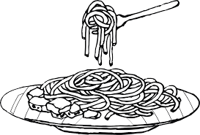
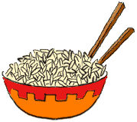

__ __ __ __ __ __ __ __ __
c e r i
__ __ __ __
a e t t p h s i g
i s c h p
__ __ __ __ __
s a p a t
__ __ __ __ __

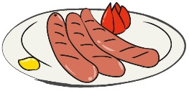
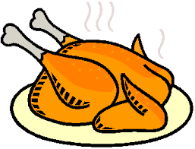
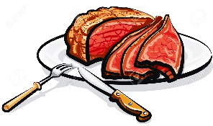
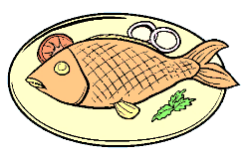

__ __ __ __ __ __ __
c h c n e k i
i s f h
__ __ __ __
s g a e s u a s
__ __ __ __ __ __ __ __
__ __
t e m a
__ __ __ __

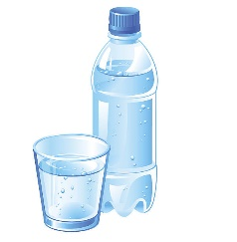
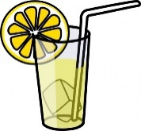
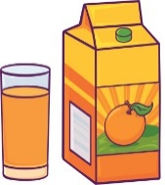

__ __ __ __ __ __ __ __

j e i c u
__ __ __ __ __
o l m e n a e d
r w a e t
__ __ __ __ __
s g e g
__ __ __ __

2) Answer.
a) What’s your favourite food? It’s ____________________ and ___________________.
b) And to drink, what do you like? I like ____________________.

ANSWER KEY

EXERCISE 1
pasta / rice / spaghetti / chips
meat / chicken / fish / sausages
eggs / juice / lemonade / water

EXERCISE 2
Suggestion
- It’s sausages and chips.
- I like water.

