|  |  |  |
| --- | --- | --- |
| **Name:** ____________________________ **Surname:** ____________________________ **Nber: ____ Grade/Class:** _____ | | |
| **Assessment:** _____________________________ | **Date:** ___________________________________________________ | |
| **Teacher’s signature:**  **___________________________** | **Parent’s signature:**  **___________________________** |

1. 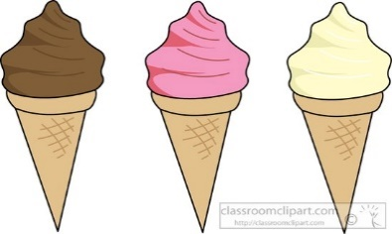**Write and match.**

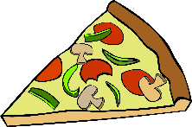

1. P __ __ z __
2. B __ s __ u __ t __
3. I__ __ c__ e __ m
4. H __ __ b __ __ g __ r
5. T __ a __ t
6. C __ i __ p s
7. S __ __ d w __ c __
8. Y __ g __ __ t
9. M __ __ k
10. C __ k __
11. C __ r __ __ l
12. C h __ __ s __
13. T __ __

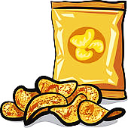

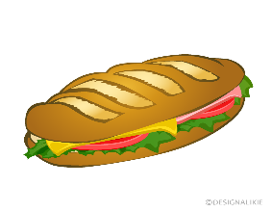

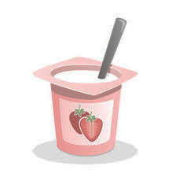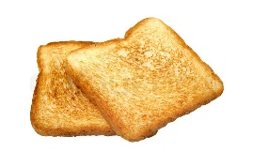

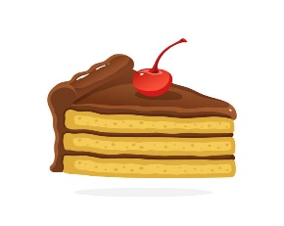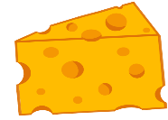

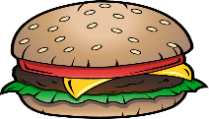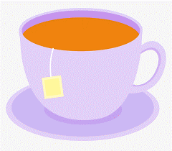

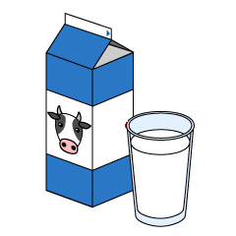

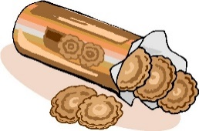

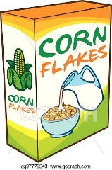

**2) Answer.**

What’s your favourite snack? It’s ____________________

**ANSWER KEY**

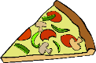EXERCISE 1

1. pizza

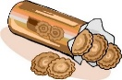

1. biscuits

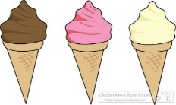

1. ice cream

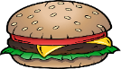

1. hamburger

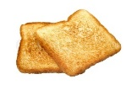

1. toast

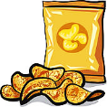

1. chips

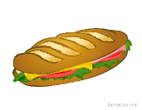

1. sandwich

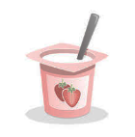

1. yogurt

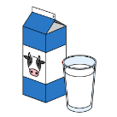

1. milk

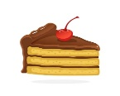

1. cake

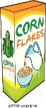

1. cereal

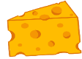

1. cheese



1. tea

EXERCISE 2

Suggestion:

It’s milk and biscuits