Name: ____________________________ Surname: ____________________________ N^{ber}: ____ Grade/Class: _____
Assessment: _____________________________ | Date: ___________________________________________________
 | Teacher’s signature:  ___________________________ | Parent’s signature:  ___________________________

1) Write about your favourite dish.

Hello!
________________________________ (name) and _____________________________ (age).
My favourite dish is _____________________________________________________________
but I ________________ ______________________________.
To drink, I ______________ _____________________.
My favourite dessert is __________________________.

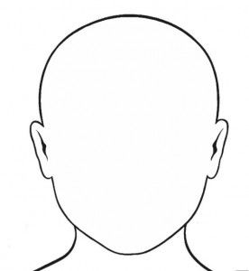

2) Draw and label.
This is me

