Name: ____________________________ Surname: ____________________________ N^{ber}: ____ Grade/Class: _____
Assessment: _____________________________ | Date: ___________________________________________________
 | Teacher’s signature:  ___________________________ | Parent’s signature:  ___________________________

Read and complete the letter.

My meals
I have b__ e __ k __ __ s __ at s________________ o´clock in the morning. I have m___________
and c________________ .
At midday, I have l__ __ c __ in the school c__________________ with my friends.
I have r______________ or s__________________ with m_____________
I have an afternoon s__ __ c __ at f___________________ o´clock: I eat an a________________
or a s______________________ and I drink some j_______________
I have d__ __n__r with my family at h__________ past s____________
We have p_______________ f_______________ and v________________
I love healthy food. I’m a healthy girl.
Lucy

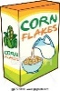
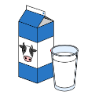

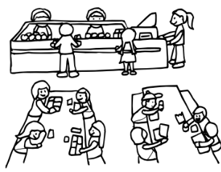

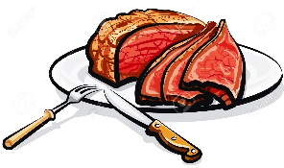
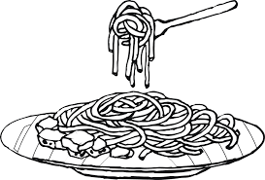
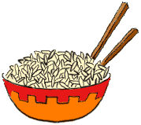

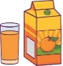

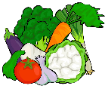
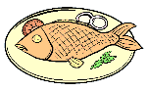
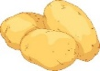

ANSWER KEY

I have breakfast at seven o’ clock in the morning. I have milk and cereal.
At midday, I have lunch in the school canteen with my friends. I have rice or spaghetti with meat.
I have an afternoon snack at four o’ clock: I eat an apple or a sandwich and I drink some juice.
I have dinner with my family at half past seven.
We have potatoes, fish and vegetables.
I love healthy food. I’m a healthy girl.

